Northumbria University

DAtabase and Analytics Principles Assesment

WeDeliver

Student:

Aleksandar Peshev

|  |  |  |  |  |  |  |  |
| --- | --- | --- | --- | --- | --- | --- | --- |
|  | | | |  |  |  |  |
|  |  |  |  |  |  |  |  |
| **Student** | Aleksandar Peshev | | | | | | |
| **Programme Title** | Computing and Technology MSc | | | | | | |
| **Module Title** | Database and Analytics Principles | | | | | | |
| **Module Code** |  | | | | | | |
| **Module Tutor Name(s):** |  | | | | | | |
| **Academic Year:** | 2021-2022 | | | | | | |
| **Coursework Title** | Database and Analytics Principles Assessment - WeDeliver | | | | | | |
| **Academic Declaration:**  *Yes, I am aware of Turnitin* | | | | | | | |
| **Word Count** |  | | | **Date Submitted** | |  | |
|  |  | | |  | |  | |
|  | | | | | | | |

Table of Contents

Section - Database 2

1.0.1 Entity Relationship Diagram for WeDeliver 3

1.0.2 a) DDL SQL Commands for the creation of the different tables 4

1.0.2 b) Populating the table with DML SQL Statements 7

1.0.3 SQL quieries 15

Section 2.0 Data warehouse 18

Figure 2: WeDeliver Star Schema 18

Section 3.0 – Data Mining 19

3.0.1 CRISP Modelling cycle for the data preparation 19

Figure 3: CRISP-DM (Wirth et al., No date) 20

The Data Preparation steps for ABM Hospital are the following: 20

3.0.2 – CVDs Machine Learning Algorithms 21

4.0 Business Intelligence – Tableau 22

4.0.1 Data Integrity Checks 22

Figure 4: Data breakdown 23

Figure 5: Address Breakdown 23

4.0.2 Warranty End Date calculation 23

Figure 22: Warranty End Date 24

4.0.3 Total Sales By City (highest to lowest) 24

Figure 6 24

4.0.4 Cities generating more than 3 million US dollars for 2019 24

Figure 7: Cities generating more that 3 million US dollars 25

4.0.5 Top selling Products 25

Figure 8 25

4.0.6 Sales By month for 2019 26

Figure 9 26

4.0.7 Sales and Profit for 2019 26

Figure 10 27

4.0.8 Maximum Sales for Boston, Los Angeles, Seattle and New York. 27

Figure 11 27

4.0.9 Dashboard for tasks 3,4,5 & 6. 28

Figure 12: Dashboard for tasks 3-6 28

References 28

# Section - Database

### 1.0.1 Entity Relationship Diagram for WeDeliver

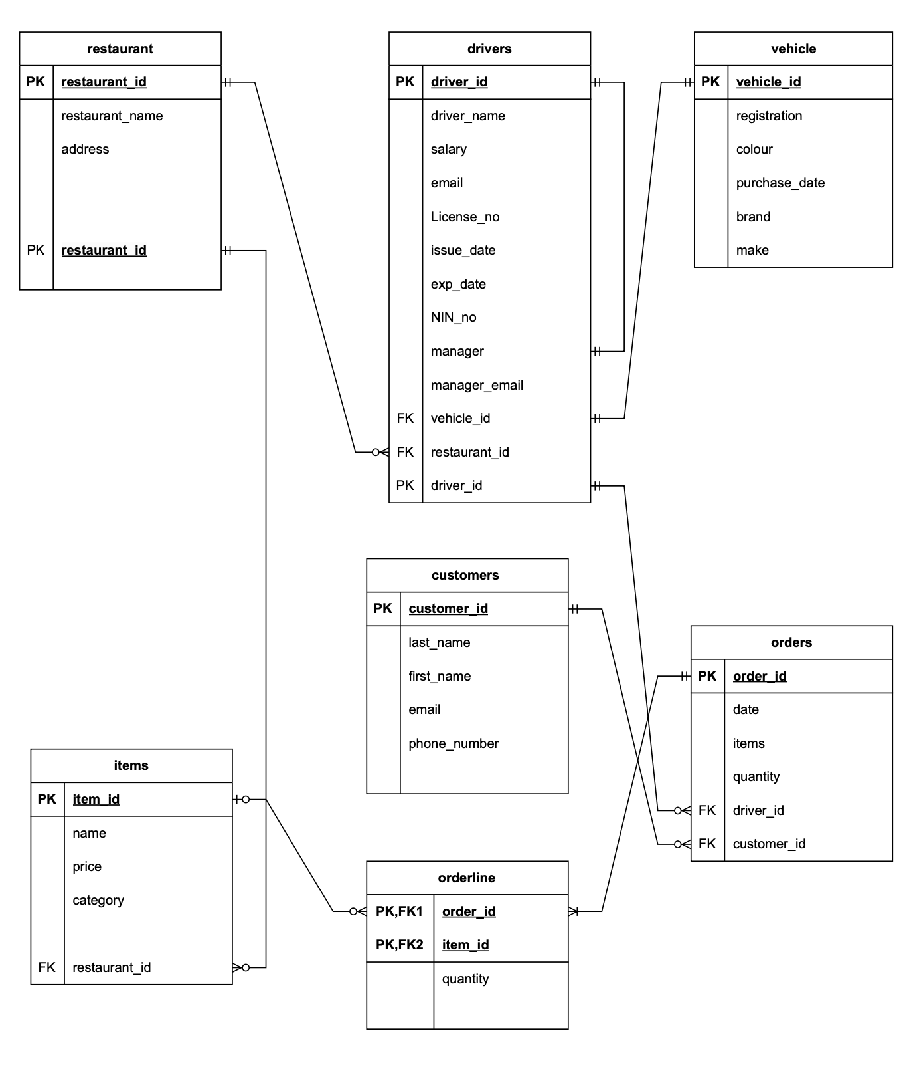

Figure

Figure 1: WeDeliver Entity Relationship Diagram

Customers(**Customer ID,** Last Name, First Name, Email, Phone Number)

Order(**Order ID,** Order Date*, Items, Quantity)

Orderline (Order ID, Item ID, Quantity)

Items (**Item ID, Restaurant ID,** Name, Price, Category)

Restaurants(Restaurant **ID,** Restaurant Name, Address)

Vehicle (**Vehicle ID**, Registration, Colour, Purchase Date, Brand, Make)

Drivers(**Driver ID, Vehicle ID, Restaurant ID,** Drivers Name, Salary, Email, License No, Issue Date, Exp Date, NIN No, Manager, Manager Email)

All of the above is from Figure 1.

Diagram 1 has all entities involved in WeDeliver’s operations. In his video, Lucidchart (2017) has discussed what is the best way to identify entity relationships between the different entities. In his opinion the best way to do it is to think logically about what is the cardinality between the different entities? When the different entities are looked at and thought over logically the following conclusions are to be drawn, in regard to the relationships between them and their cardinality.

The first relationship to be examined between restaurant and items. One restaurant can sell one or many items, but items can come from one restaurant for this reason the relationship displayed on diagram is many (optional) to one. The next one is food items to order items as displayed on Figure 1 is displayed is one to many (optional). Order items to orders relationship would be one to many (optional). Customers to orders is the next relationship, one customer can place many or one order whereas one order can have one customer. In this case the relationship is one to many (optional). The orders and drivers, relationship could be identified as one driver can deliver one or many different orders whereas an order can have one driver delivering it. Therefore, the relationship can be classified as one to many (optional). The drivers to managers relationship could be classified as self-join one to many (optional), because one manager can manage more than one driver that is assigned under them, but one or more driver is being managed by one manager. Next, drivers to bikes. One bike can be driven by one or many drivers and one or more drivers can ride one bike. Therefore, this relationship can be classified as one to many (optional). Lastly, one restaurant can have one or more drivers delivering for them, but one driver can have one restaurant at the time, so this relationship can be classified as one to many (optional) (Lucidchart, 2017)

## 1.0.2 a) DDL SQL Commands for the creation of the different tables

This the section where the Database is being created through the use of CREATE DDL statement.

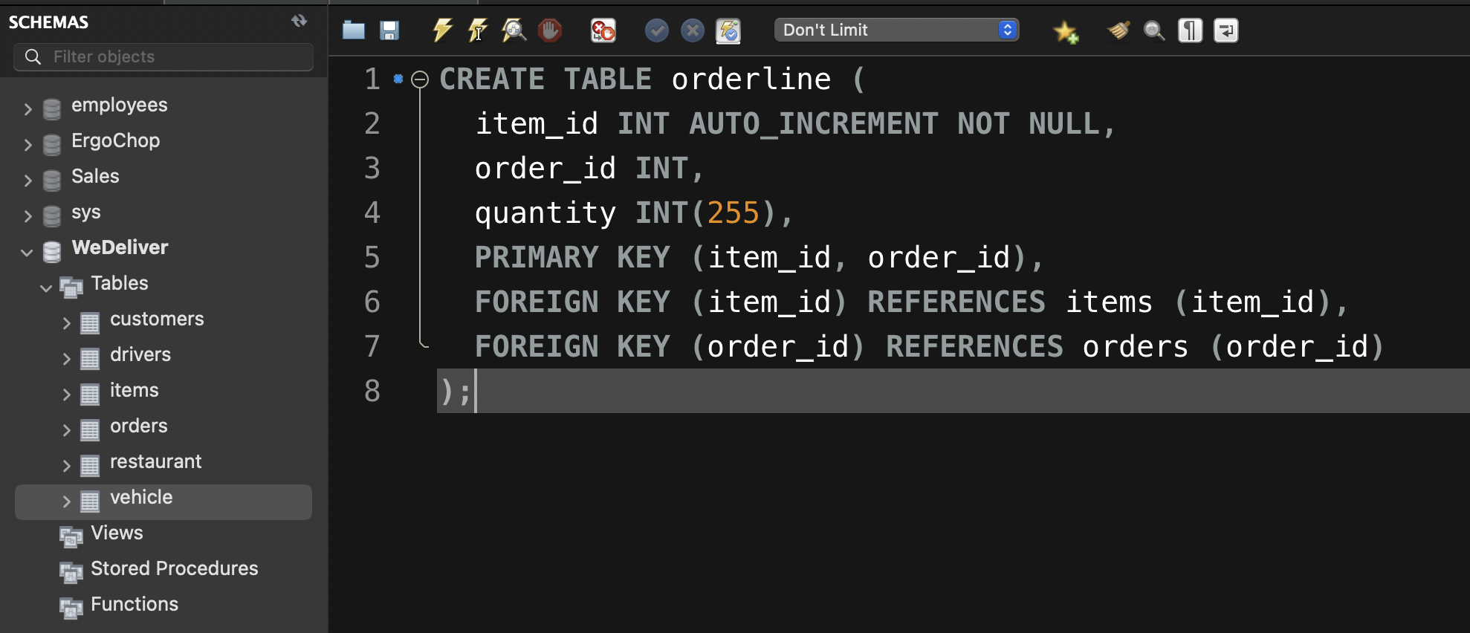

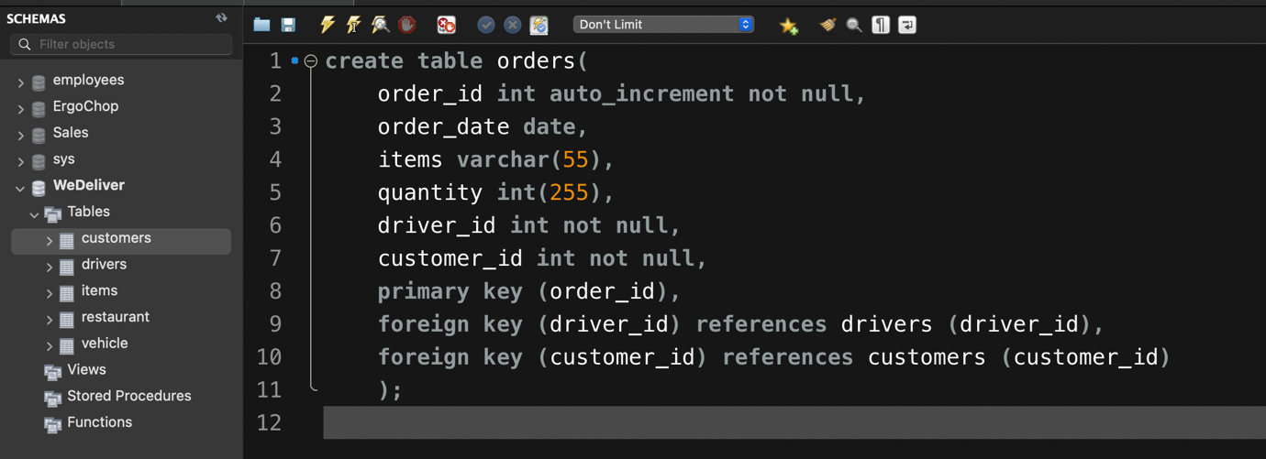

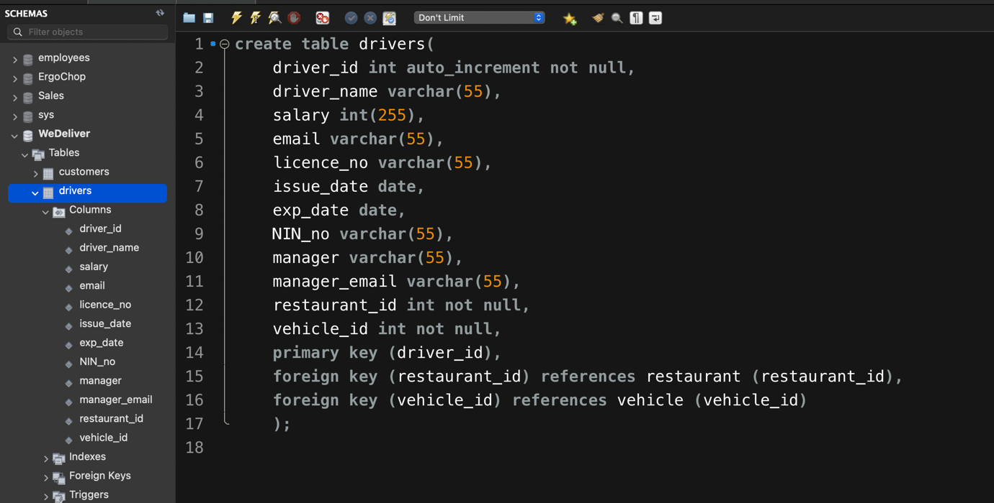

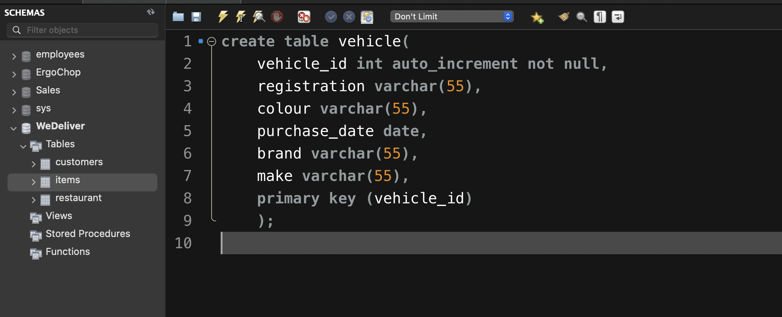

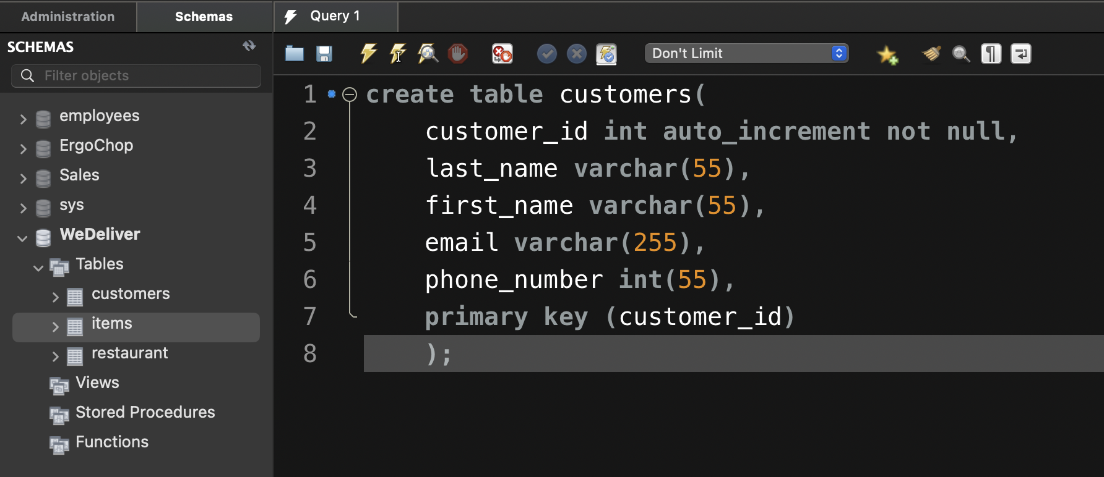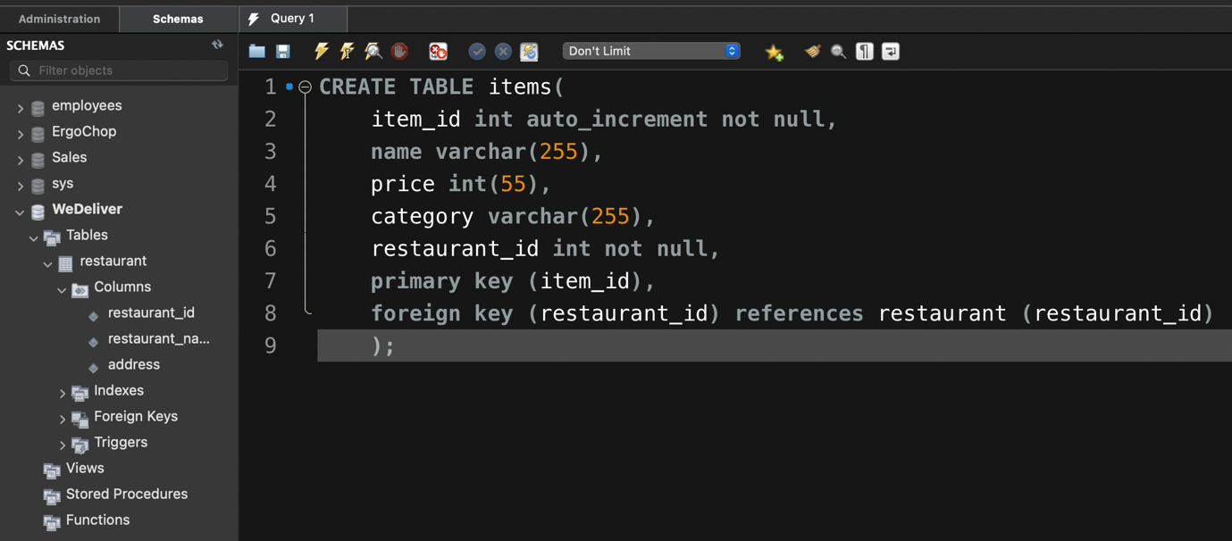

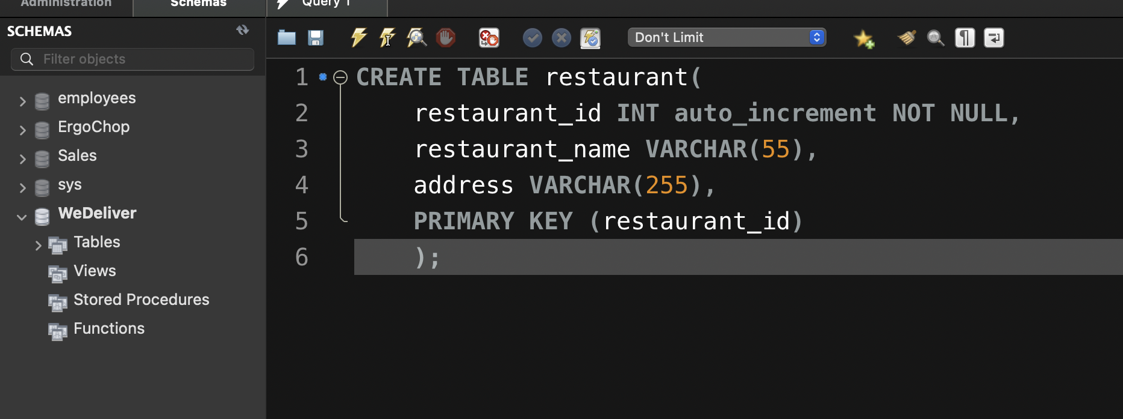

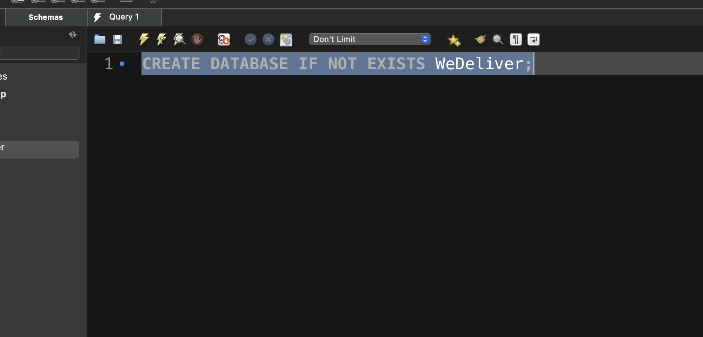

## 1.0.2 b) Populating the table with DML SQL Statements

This is the section where WeDeliver database is being populated through the use of

INSERT INTO DML statement.

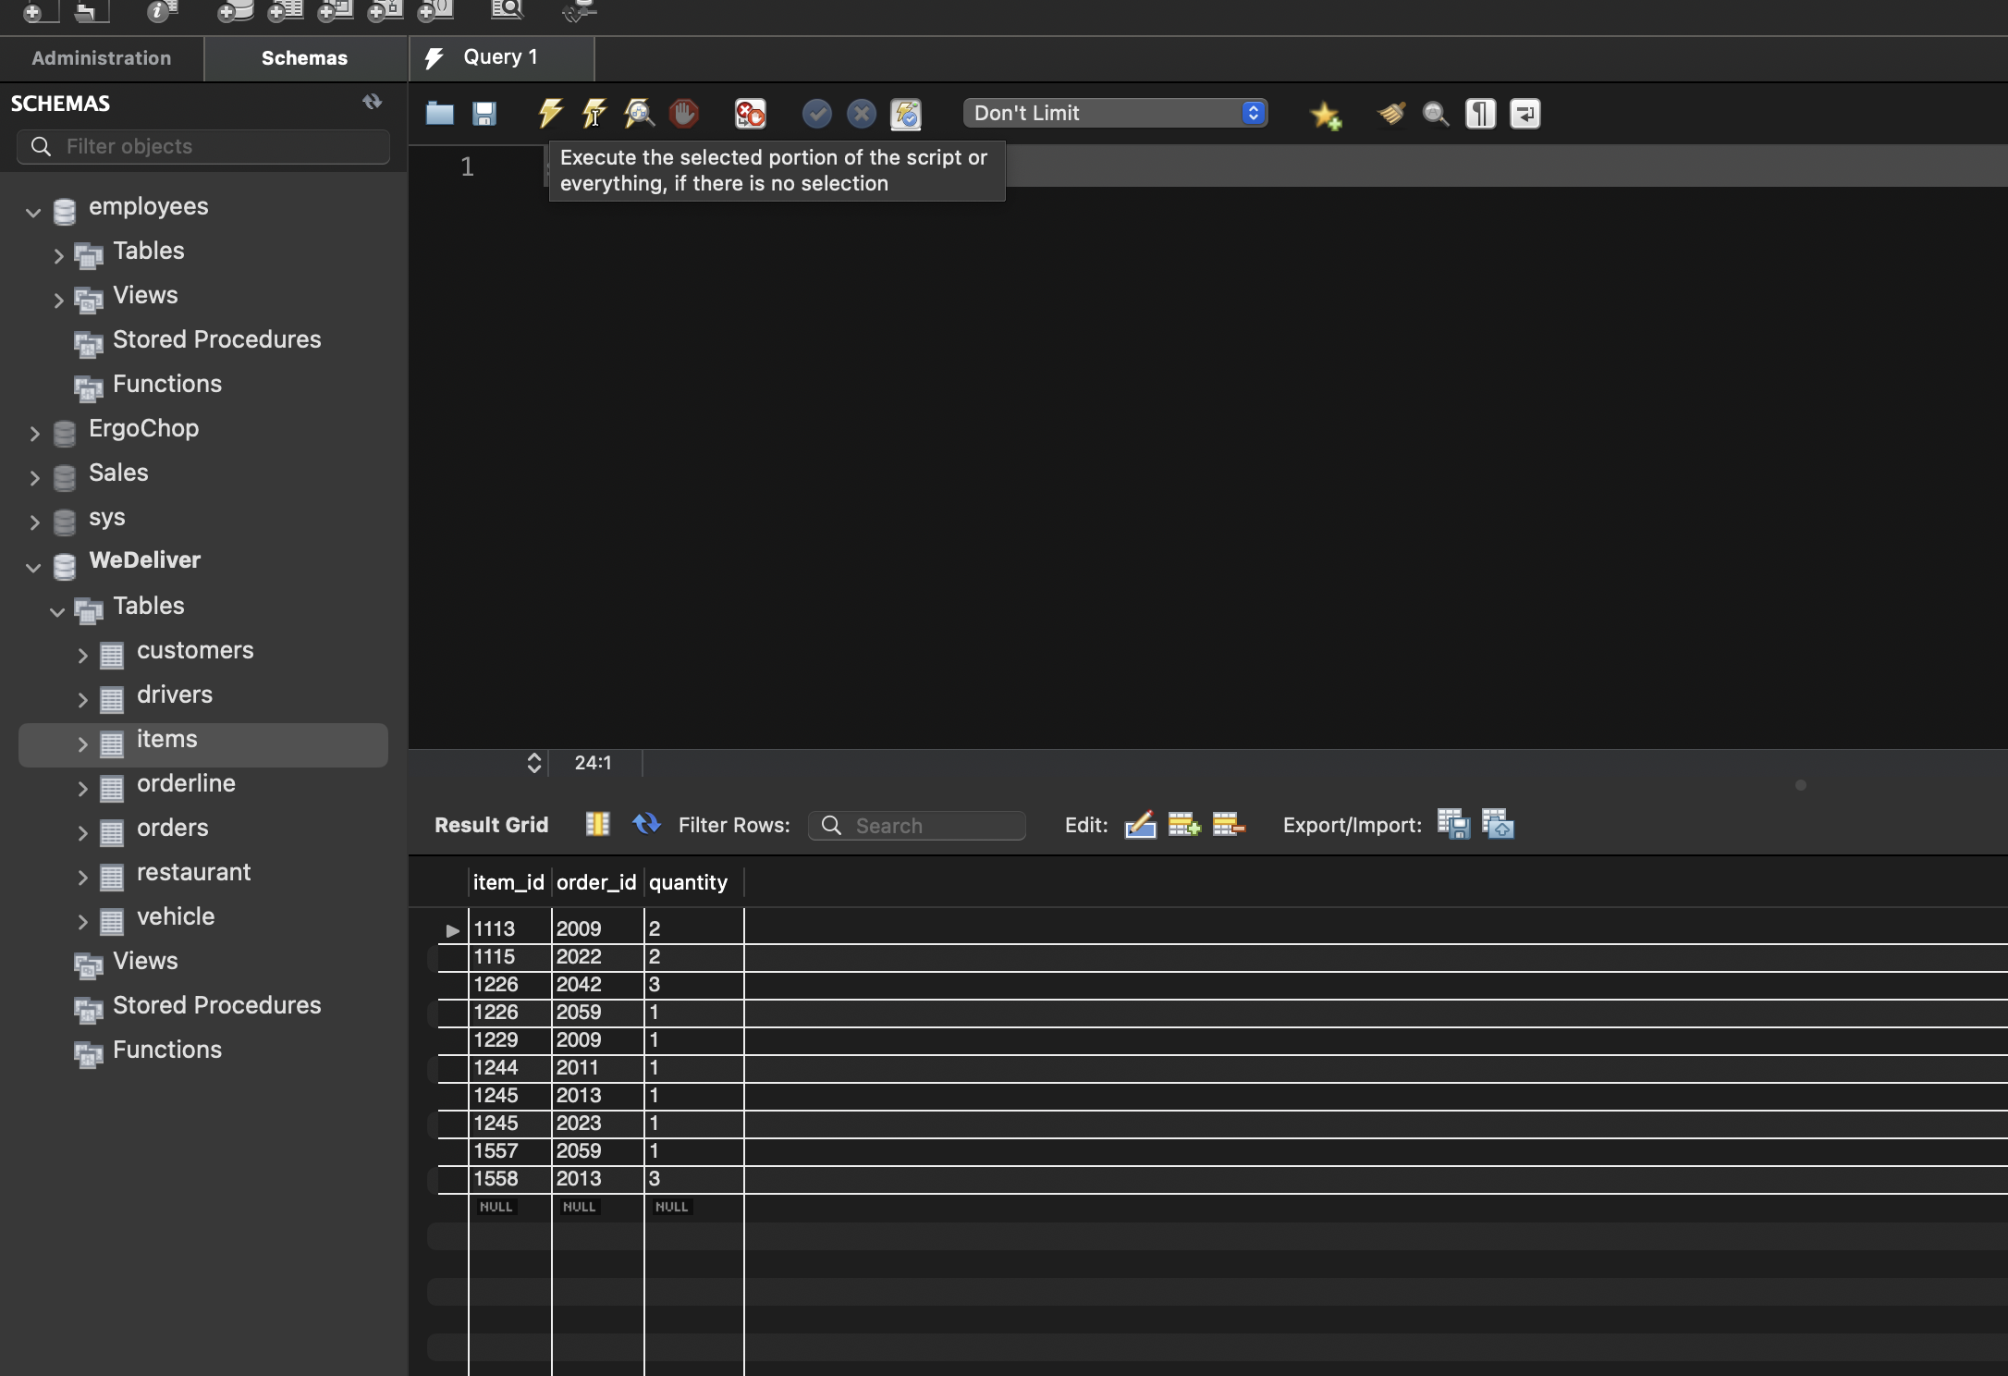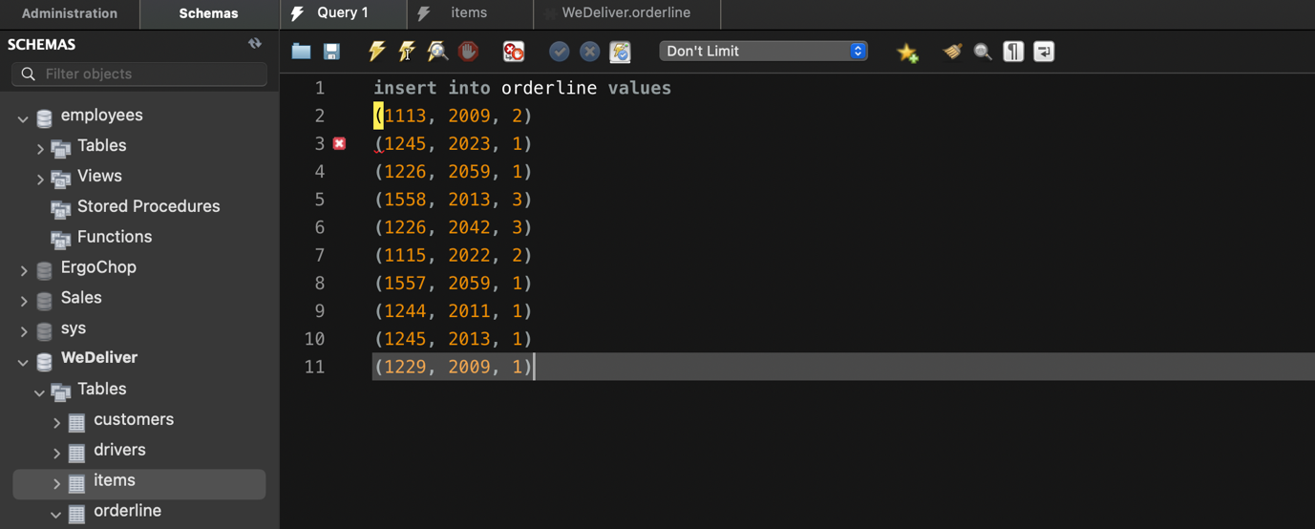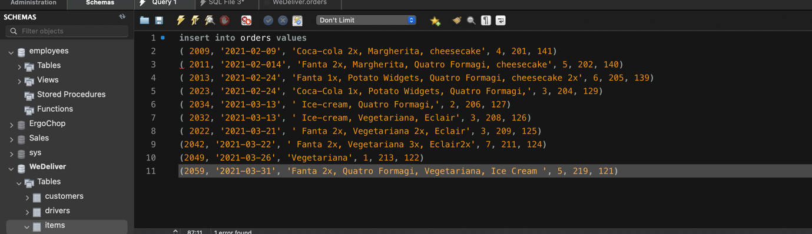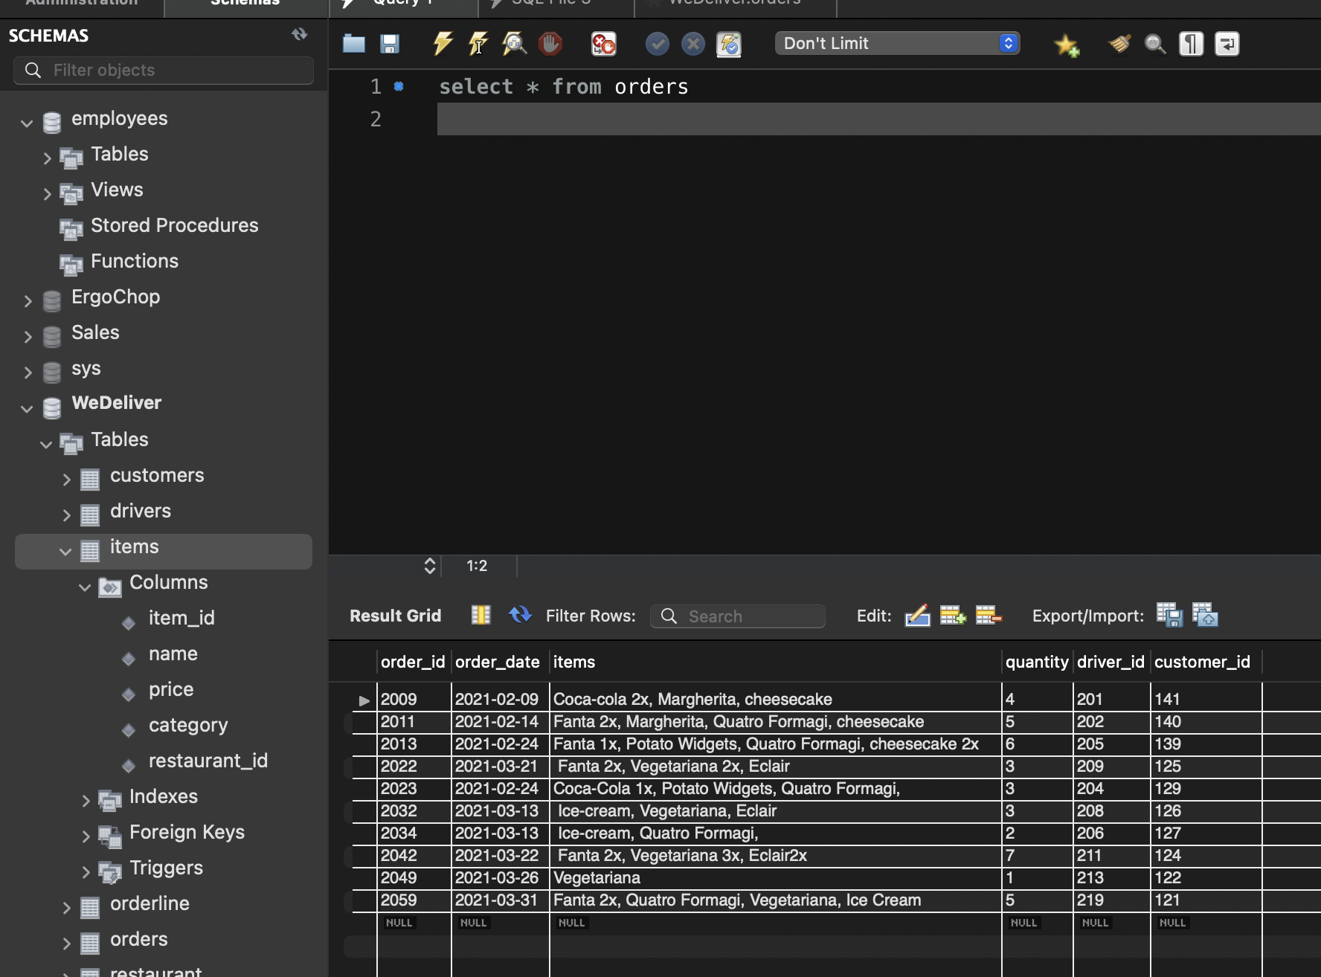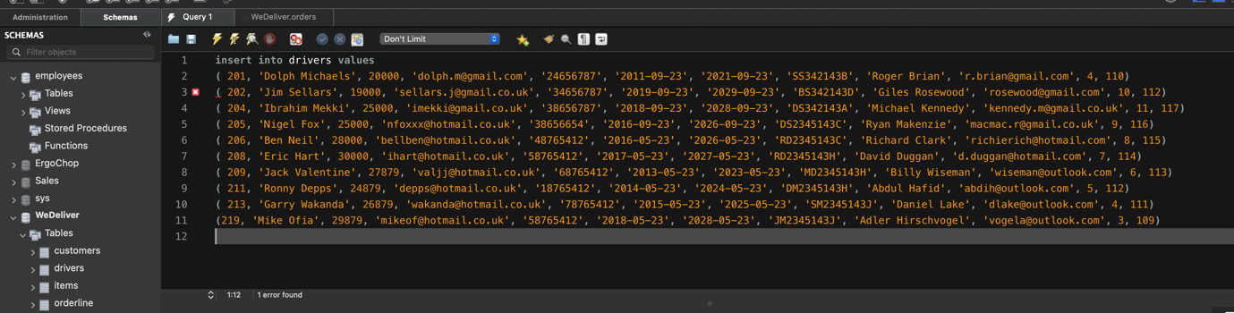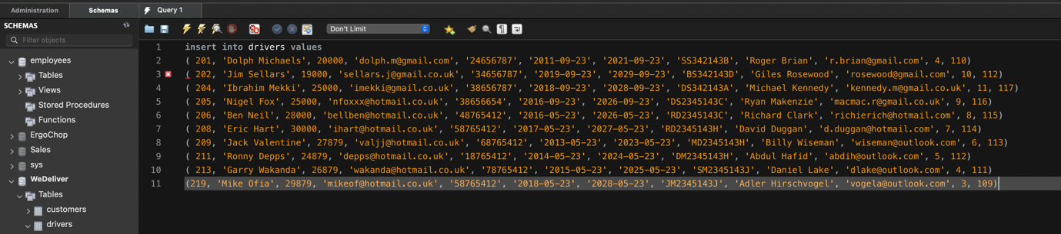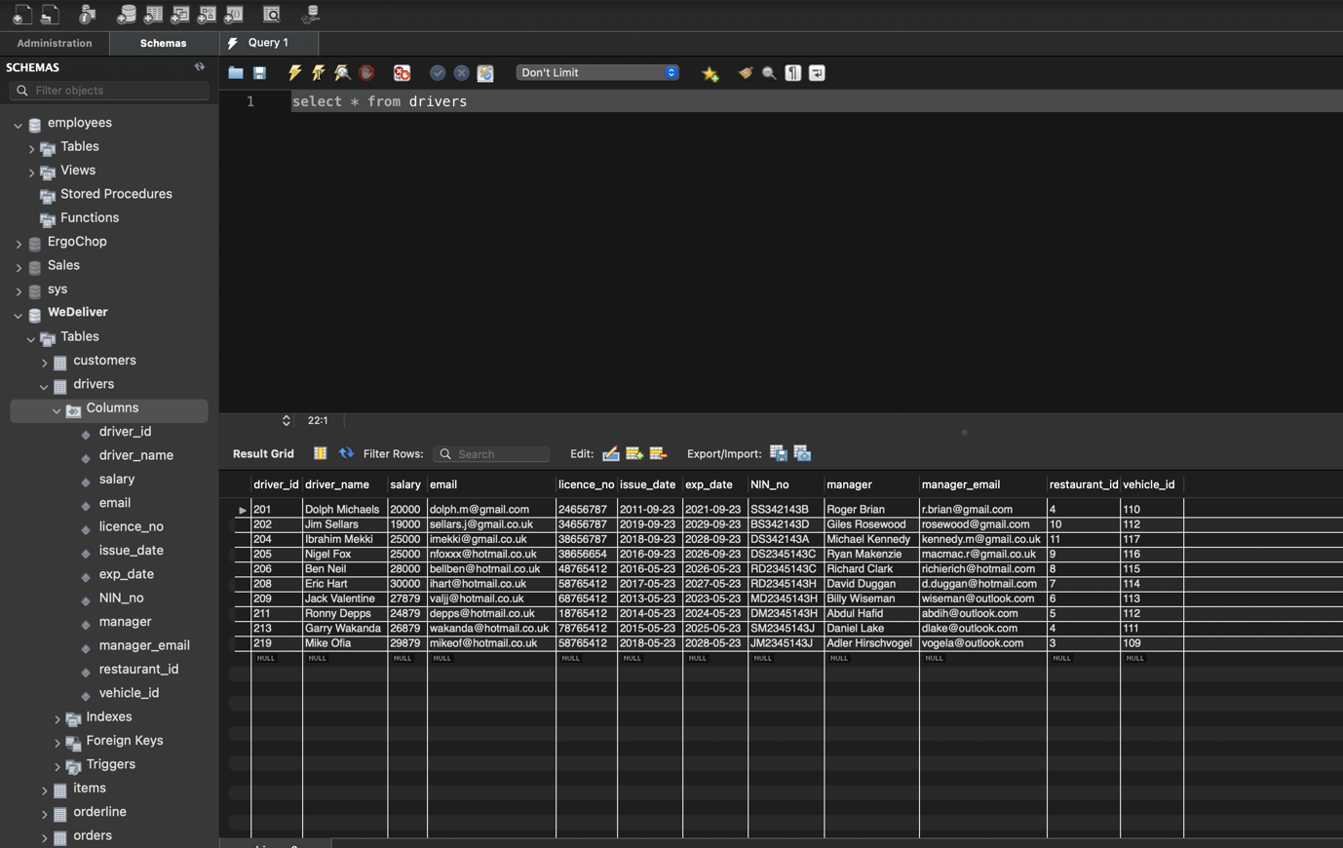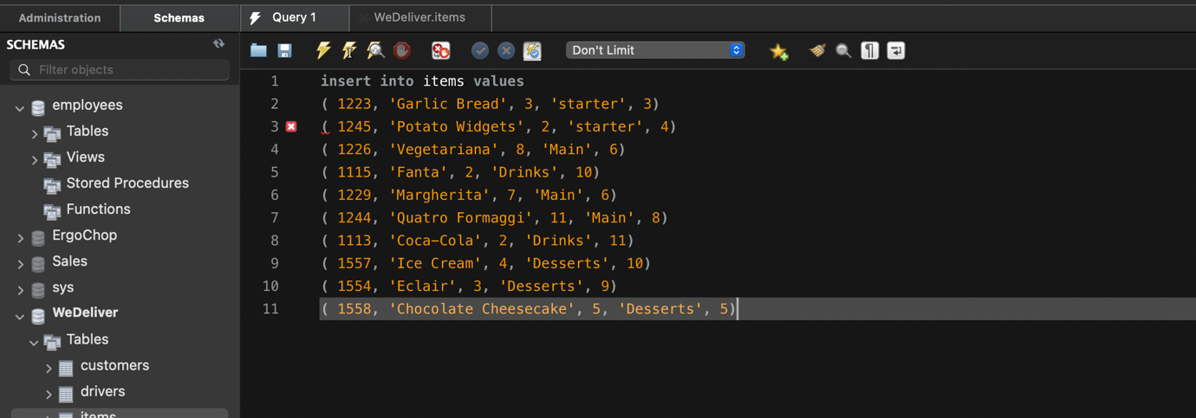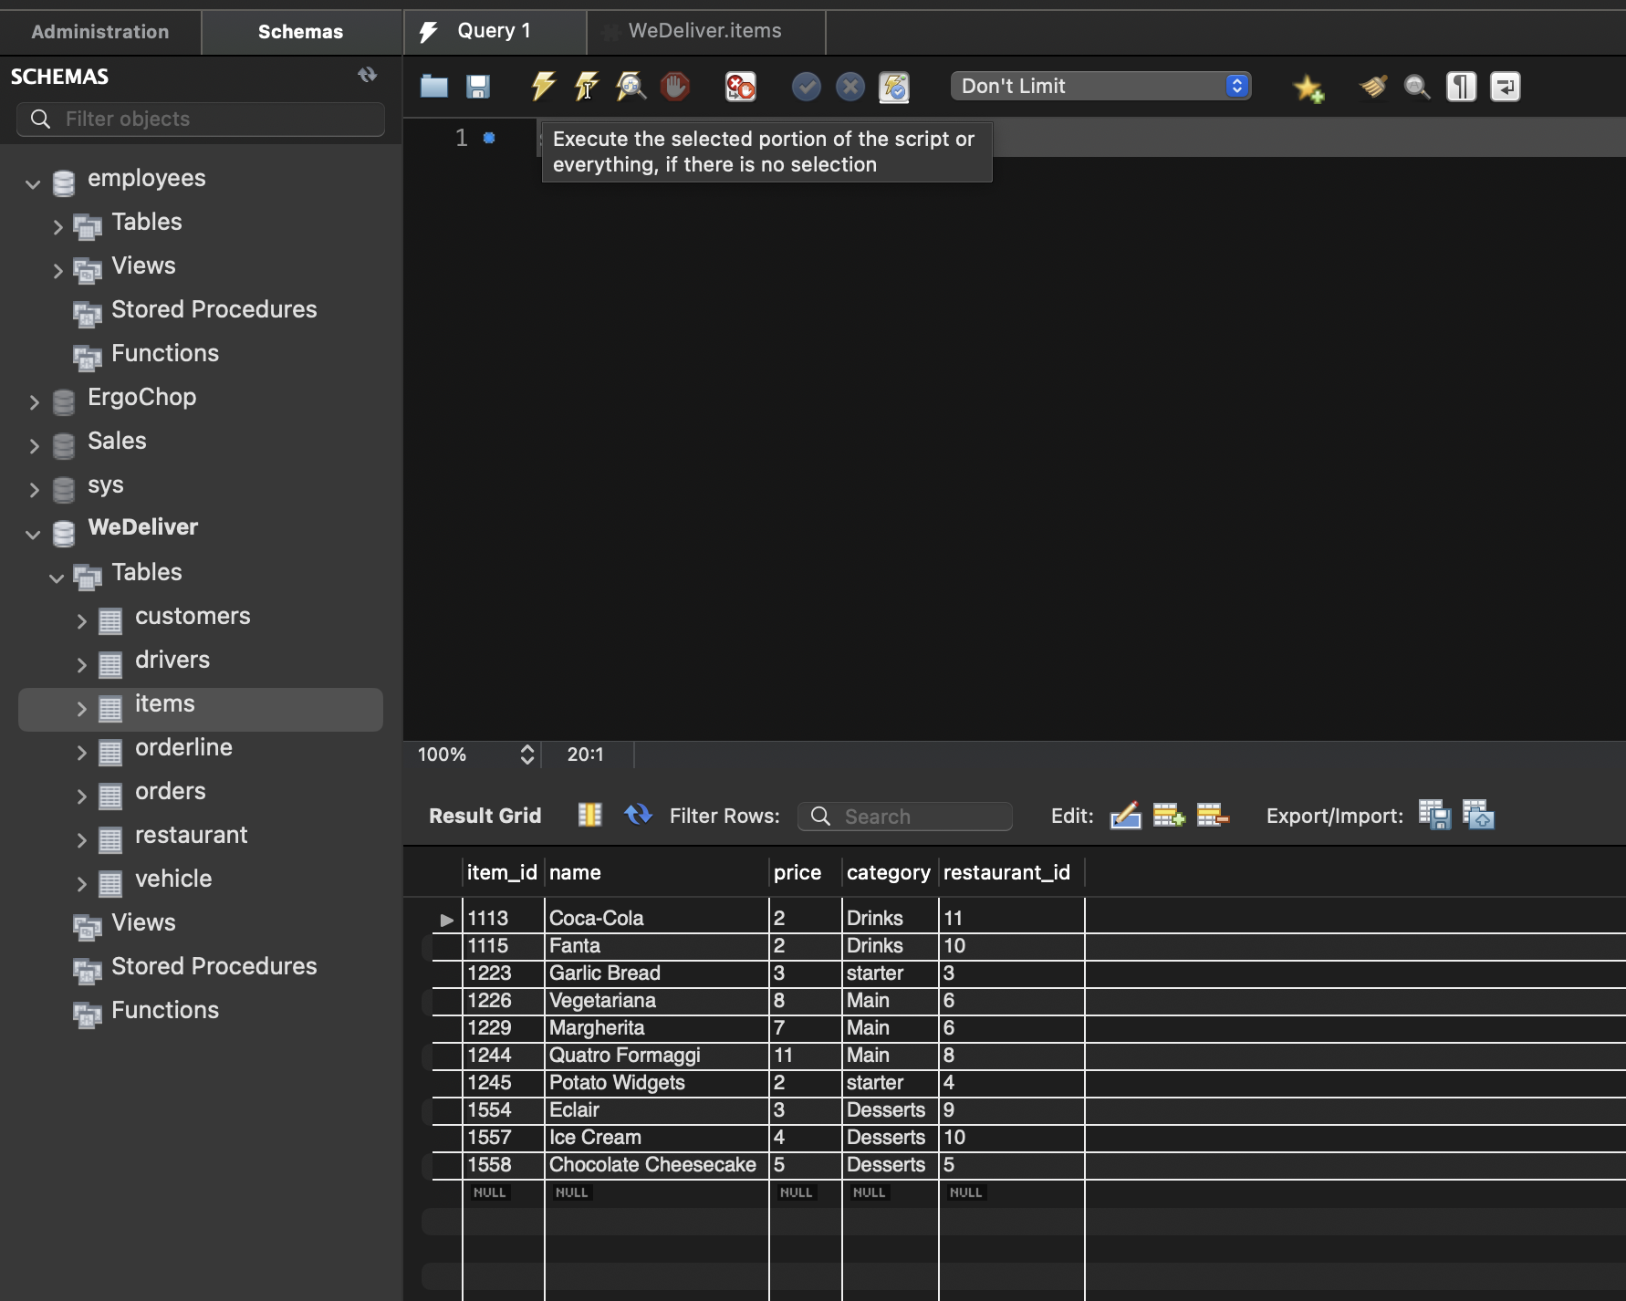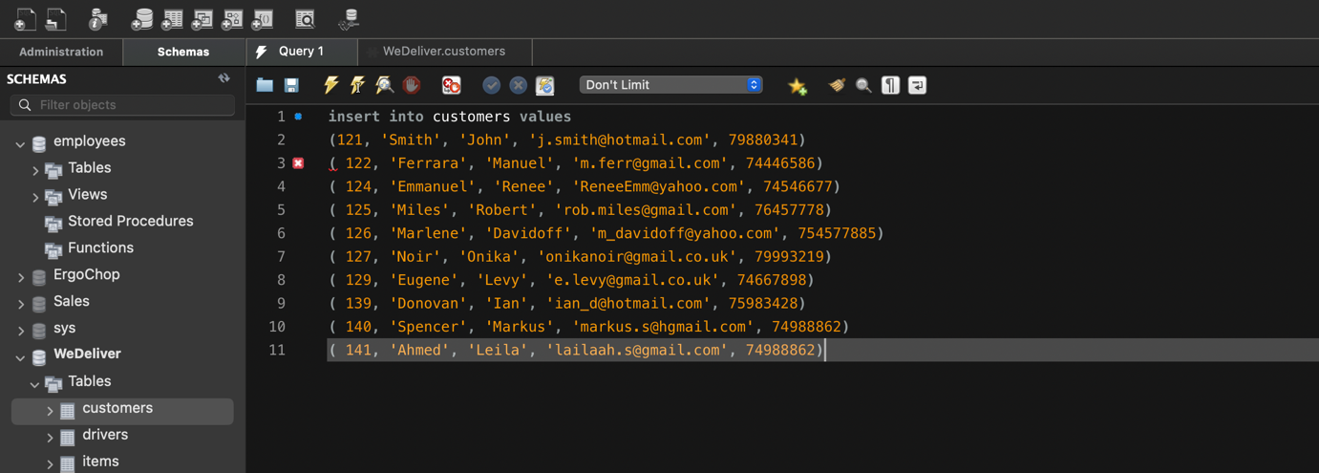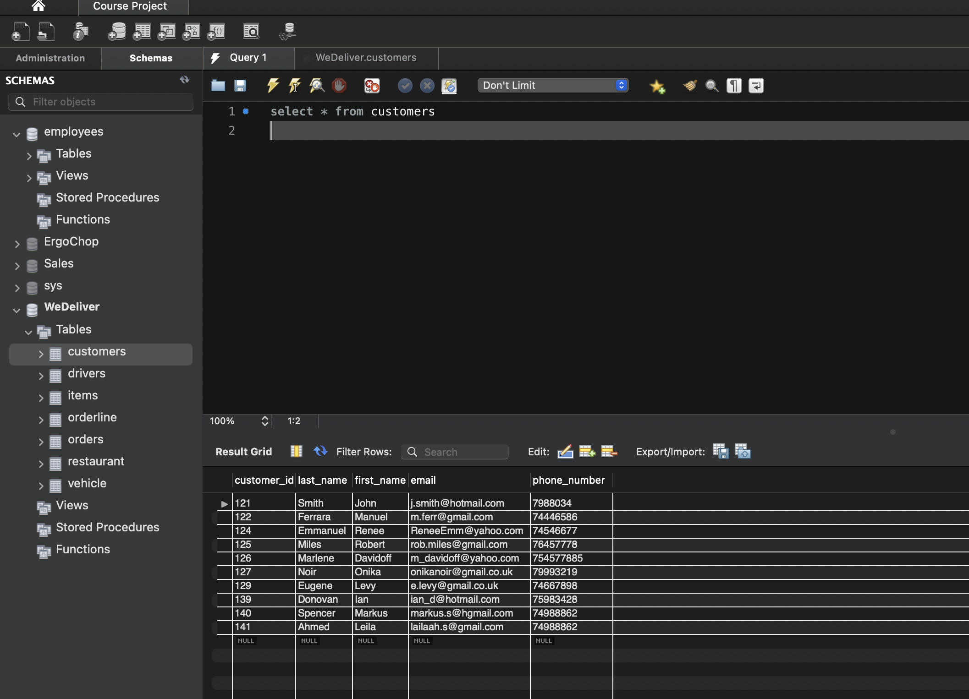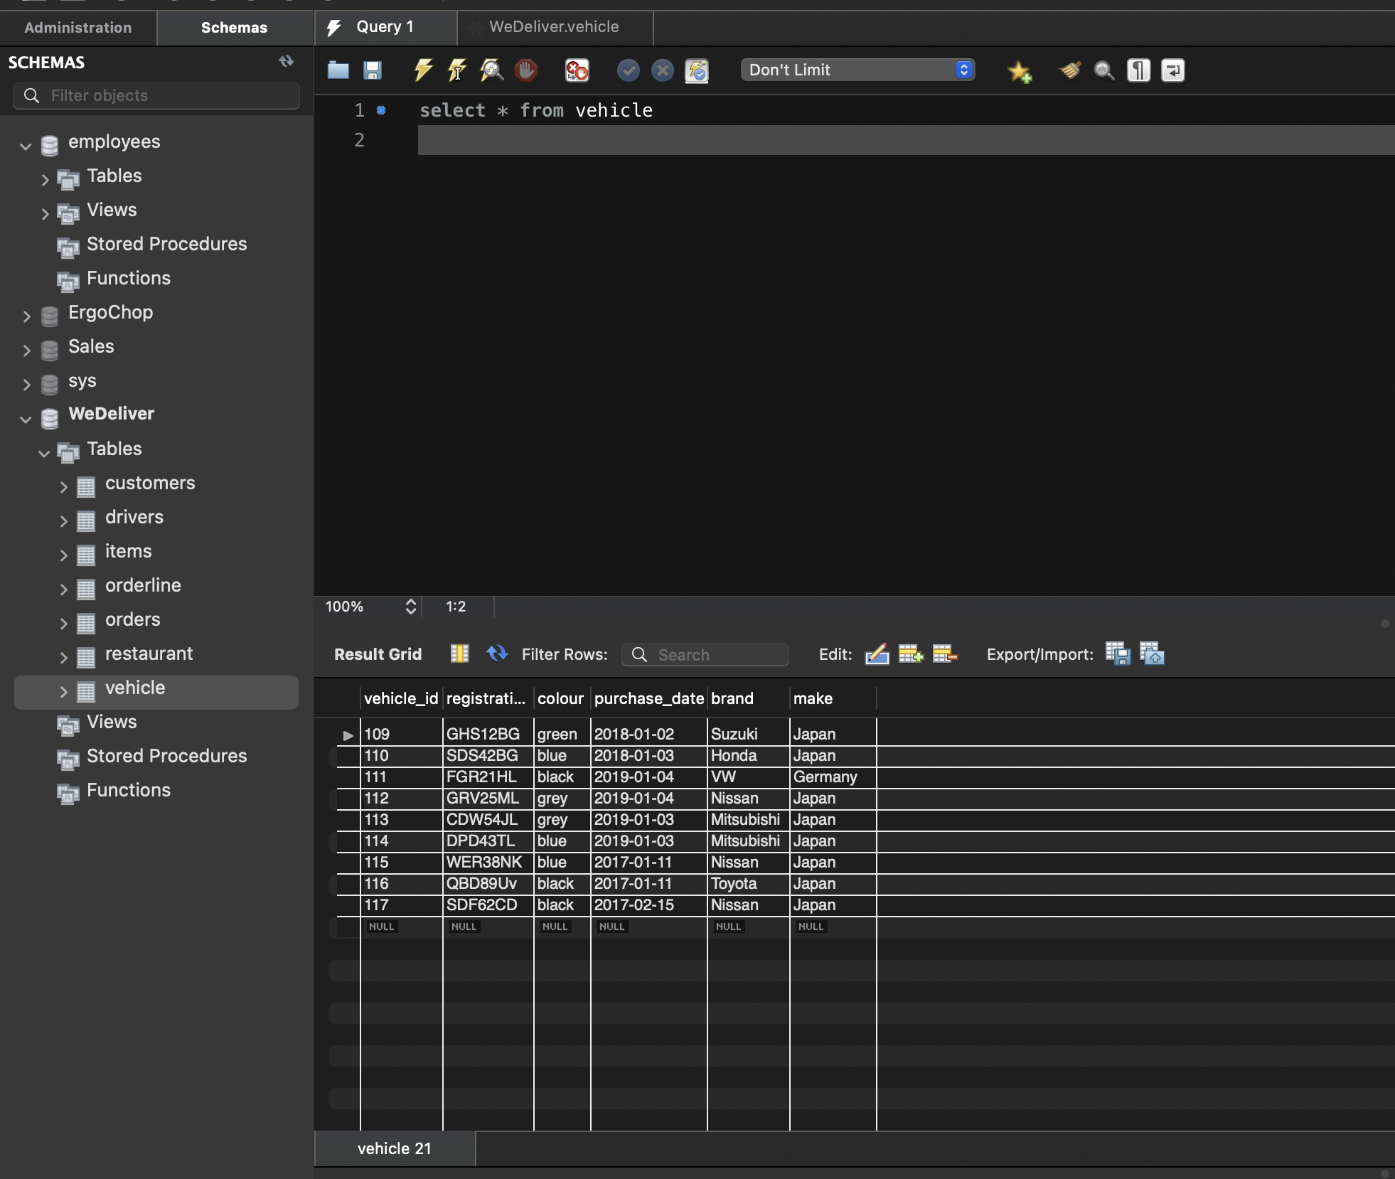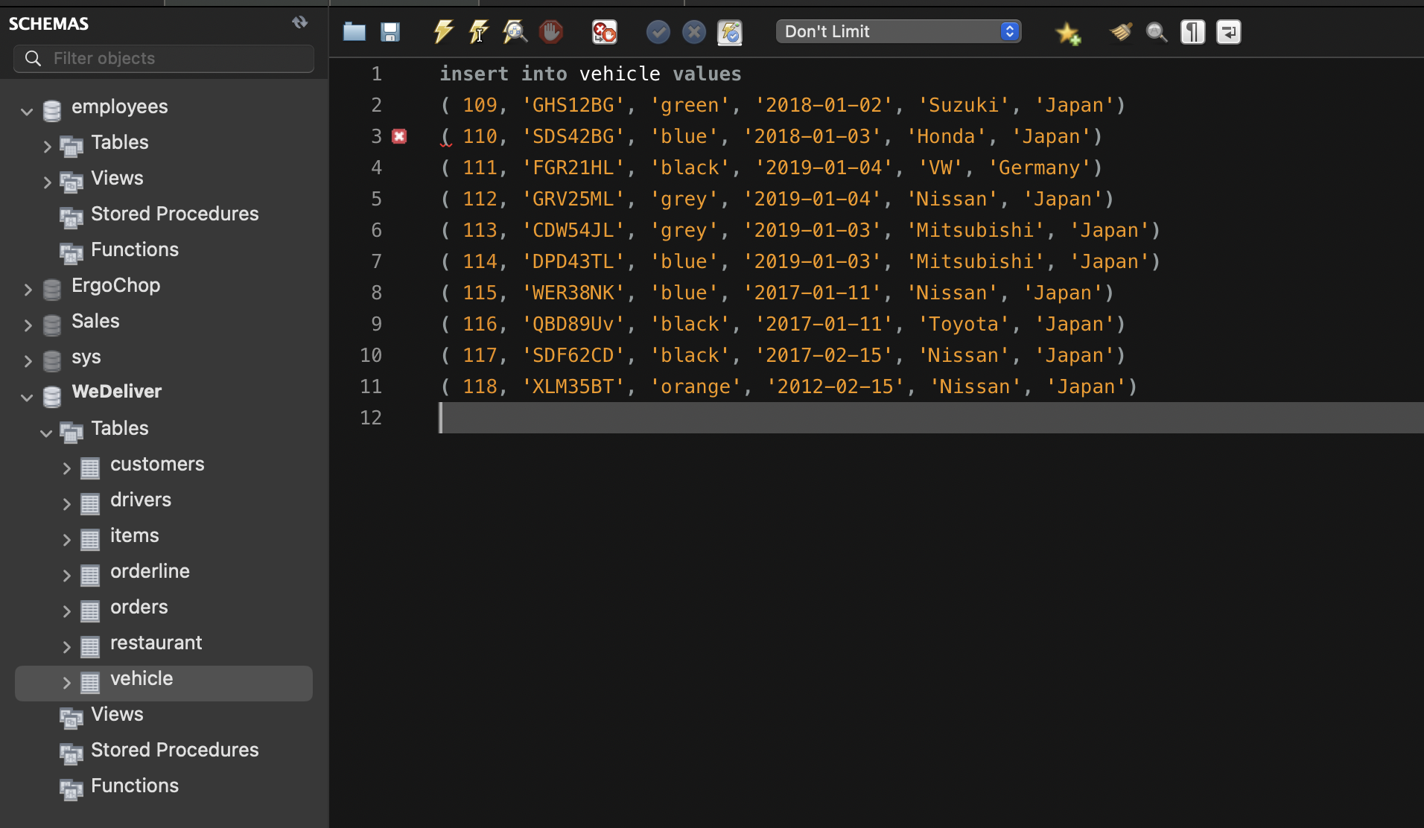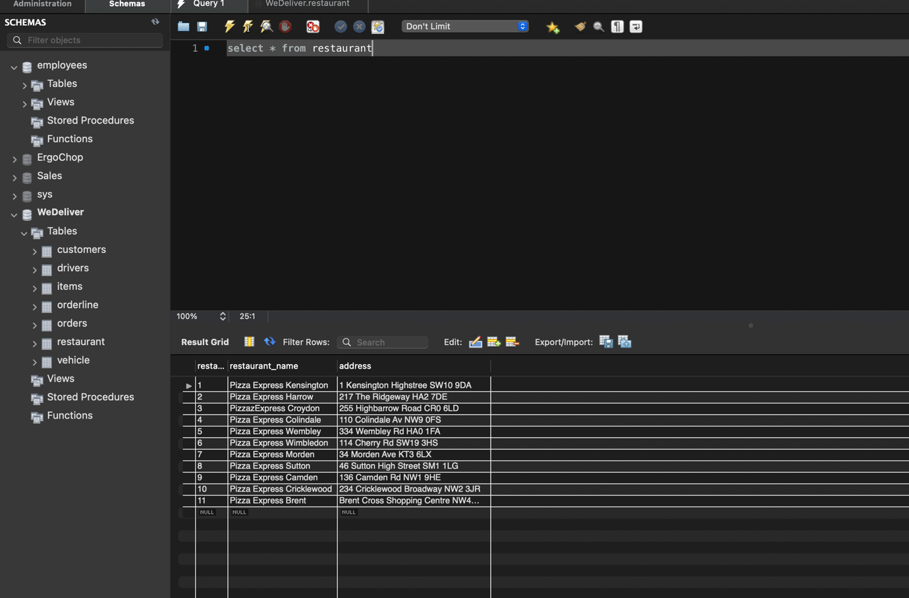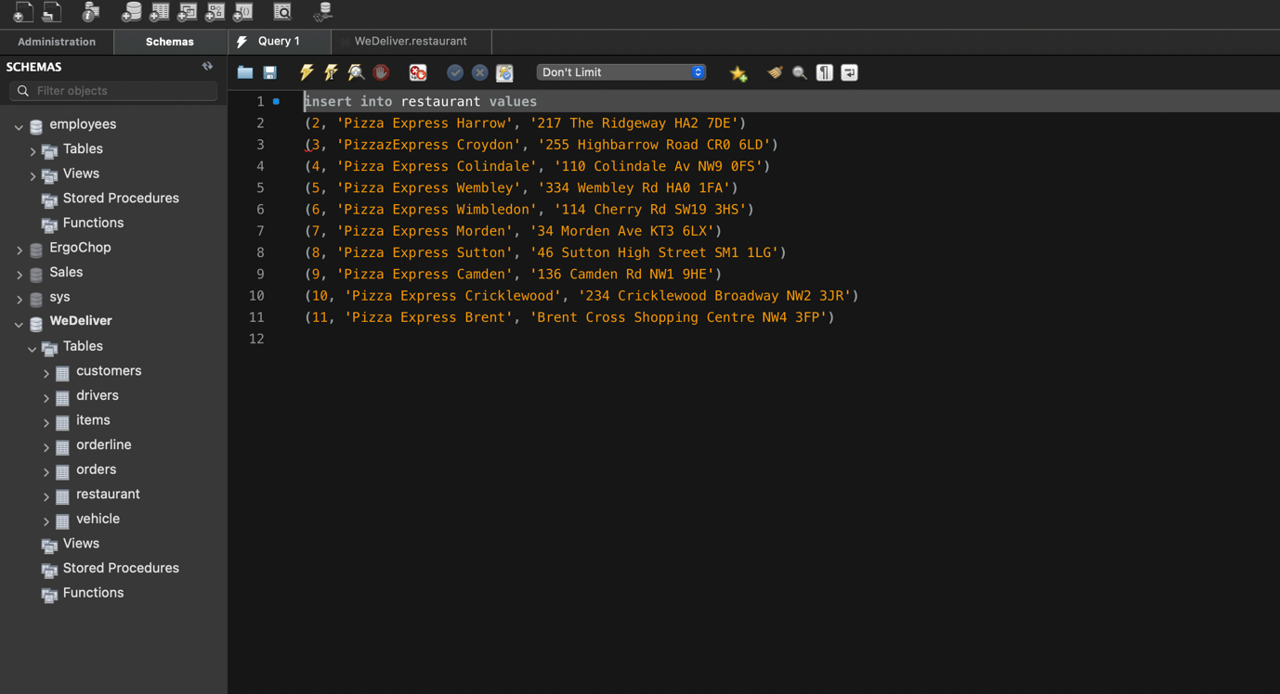

## 1.0.3 SQL quieries

This the section where 1 Self-Join, 1 Equi-Join, 1 Group function, 1 Subquery and Selectin one null value through the use of the DML SQL Statements.

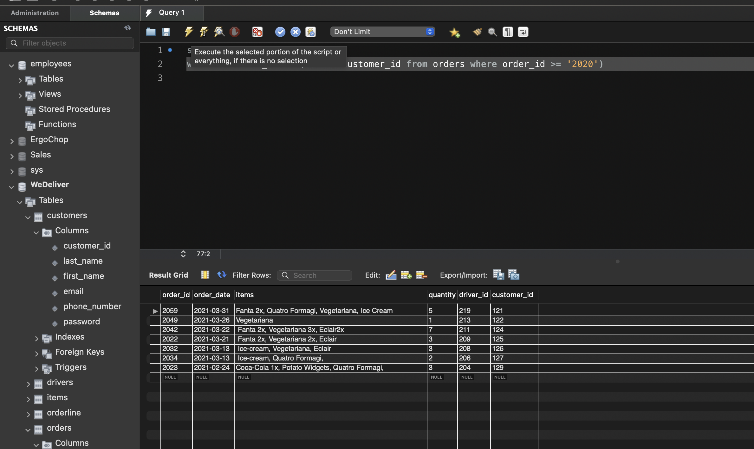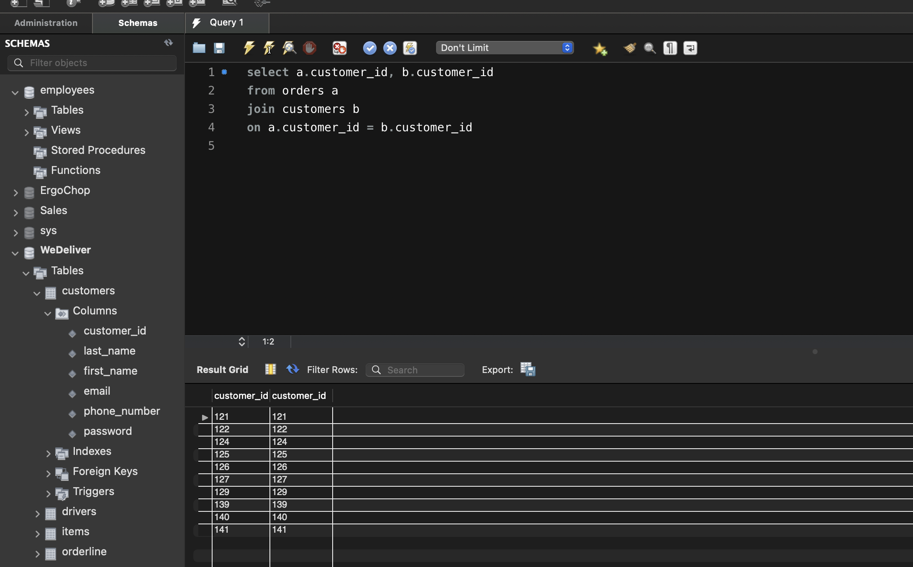

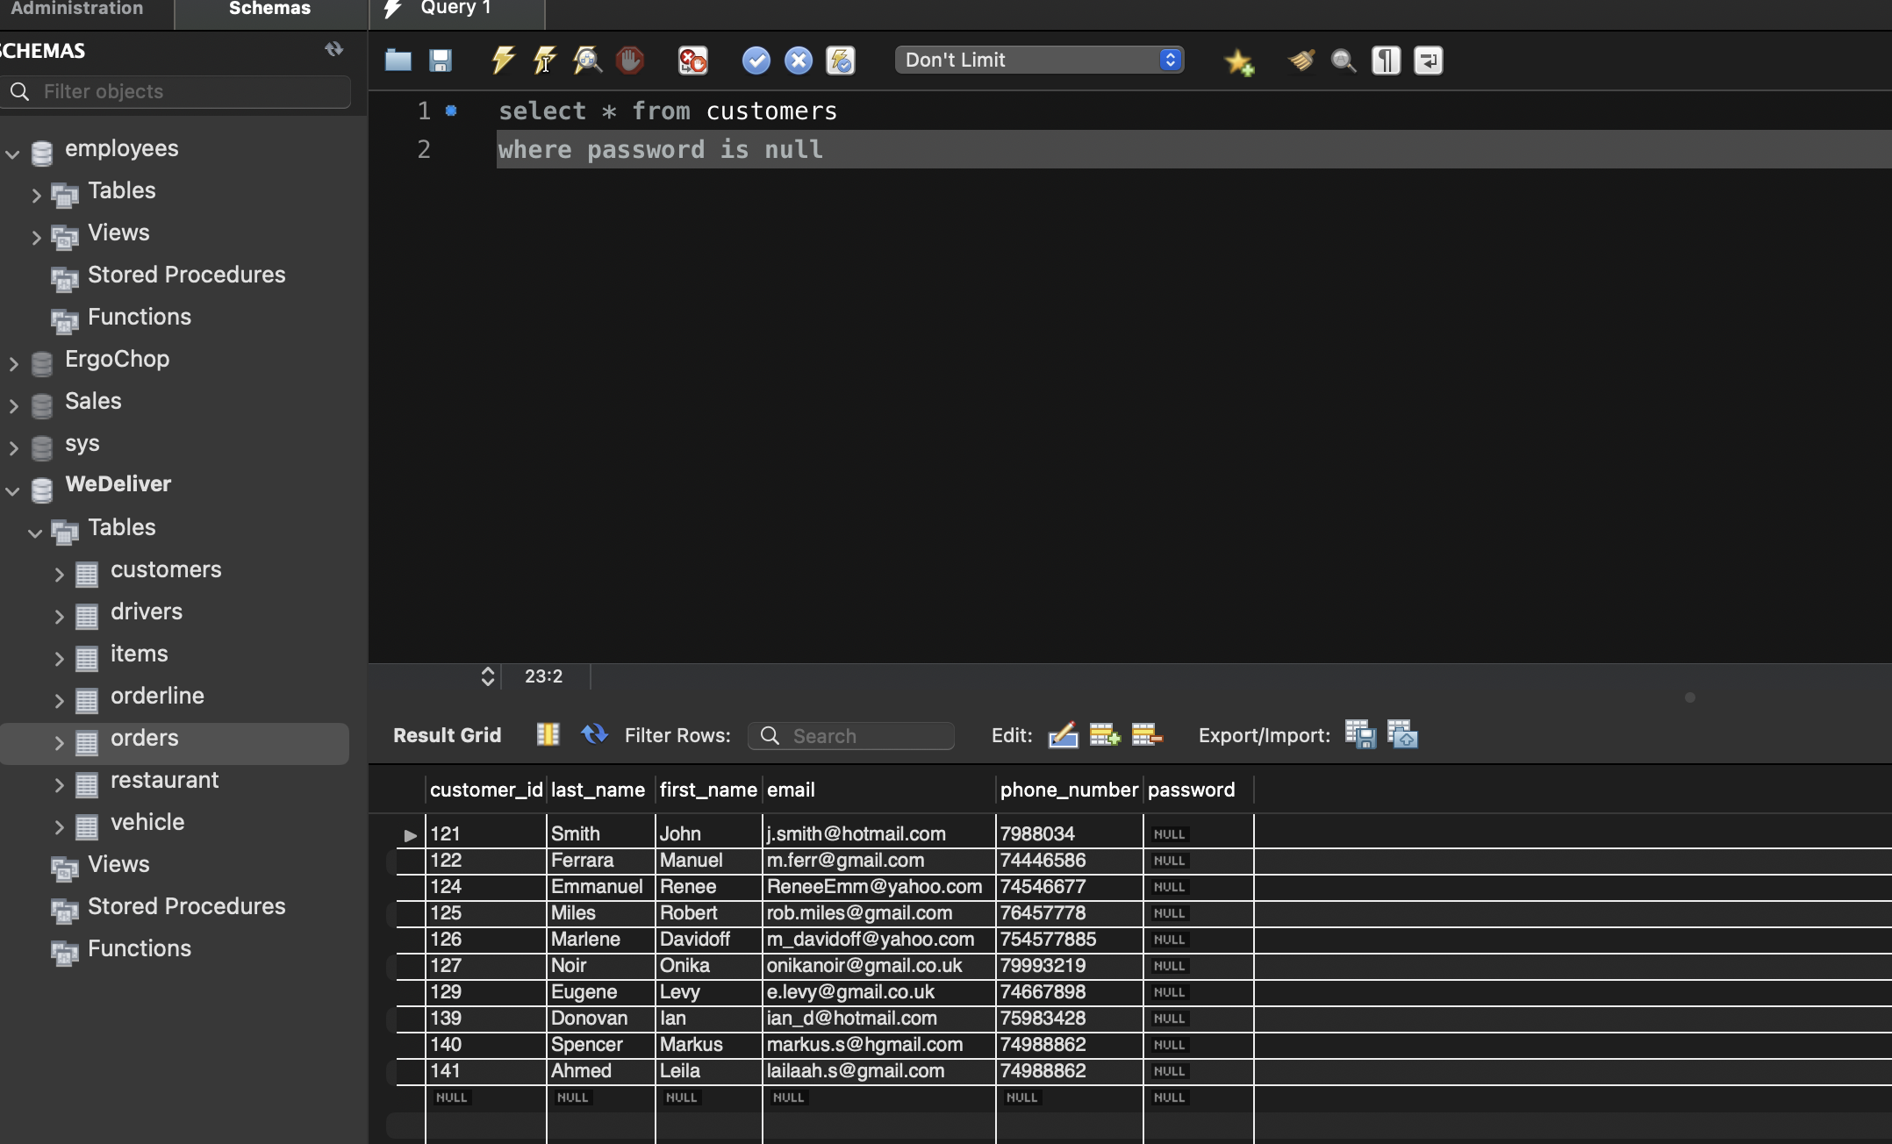

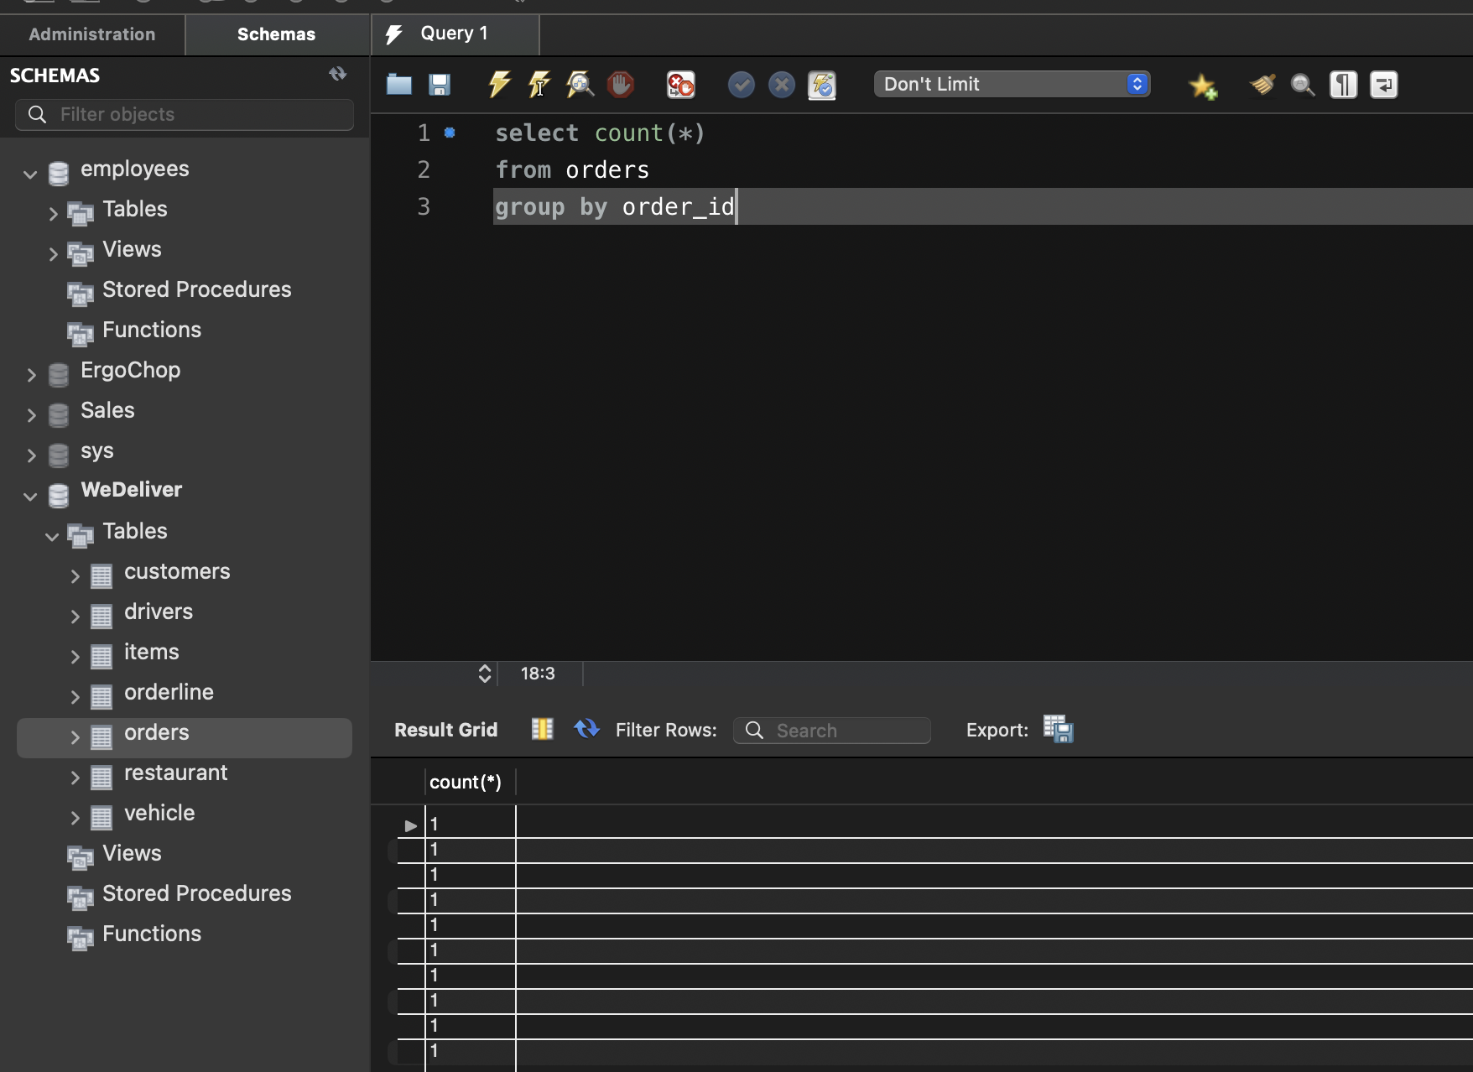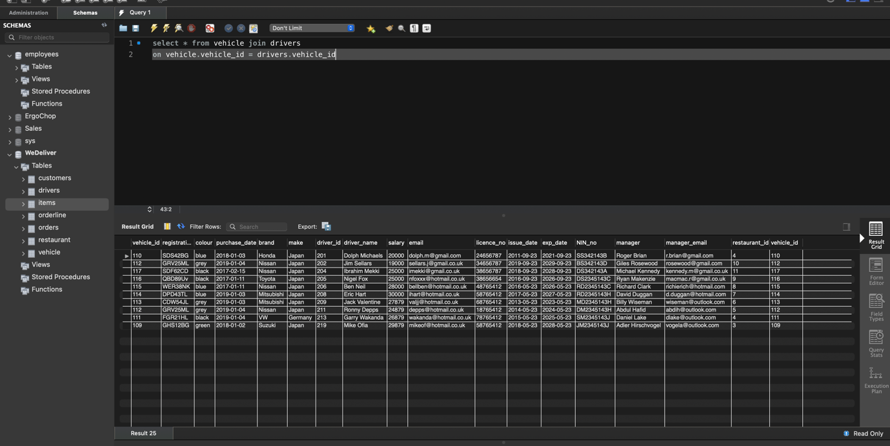

## Section 2.0 Data warehouse

This a type of data collection which is non-volatile, subject orientated, integrated, having a time variant which helps management with its decision making (Inmon, 2002).

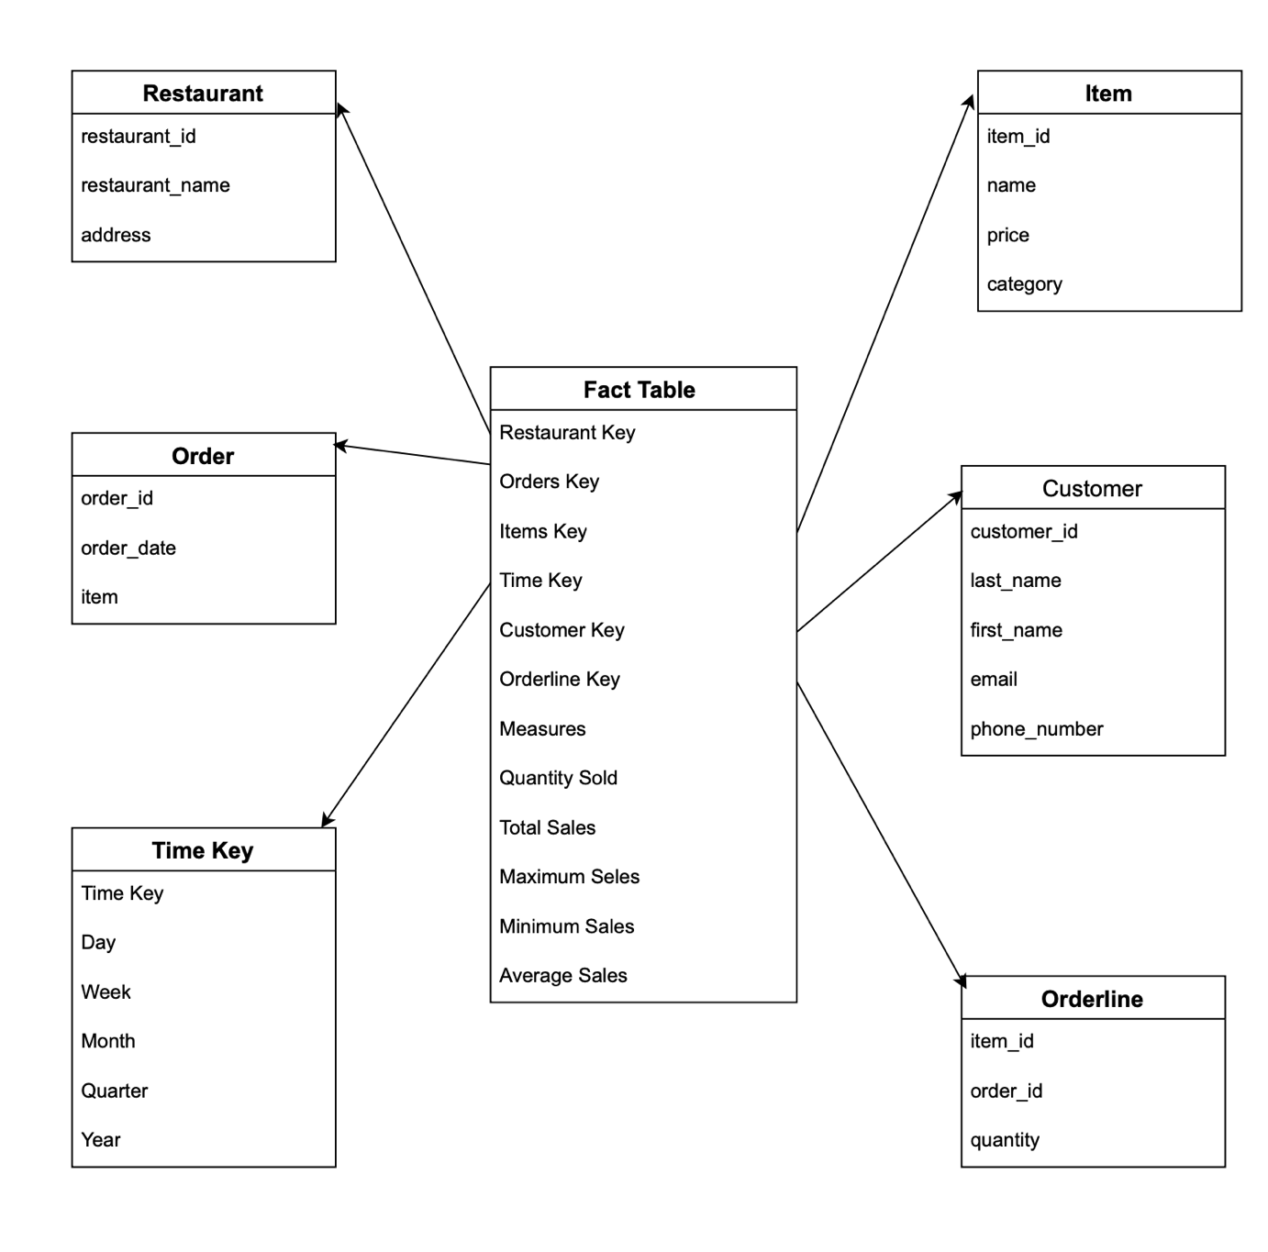

### Figure 2: WeDeliver Star Schema

The Star Schema for WeDeliver: The Star Schema is a useful tool that is a variation of dimensional model where each dimension is represented by a different table as the main table being the fact table. Moreover, the fact table is surrounded by the different dimensions on each side which resembles the form of a star if they were connected with one another.

**The main reason to choose a Star Schema is because** this kind of database model optimizes the process by simplifying the data schema joins because there are no join relationships required which will contribute to caster processing. This kind of dimensional model is also extensible which makes the possible to add changes and to withstand (Kimball, et. al., 2013). For this assessment the most useful tool would be Star Schema. Furthermore, this type of tool is used to further normalize data in databases, where it separates the different dimensions further.

**The design itself** is pretty straight forward and it consists of four steps. The **first** step is to identify the subject of the sales fact table which is going to be sales by restaurant in the areas in the city of London. **Second** step is to identify the grain, so the sales facts consist of the following: Order ID, Order Date, Item ID, Quantity, Item ID, Customer and Restaurant ID. **Third** step is to Identify the different dimensions, which are: Restaurant, Customer, Item Price, Driver and Time. **The fourth** are the Measures that consist of aggregation function, Total Quantity of items sold, average items sold, minimum and maximum items sold all in pound sterling.

Kimball’s four step design consists of the type of business process which is the sales for we deliver for the period of 22/2 to 3/3/2021. That is followed by the different levels of data (grain) that consists of the different keys. Followed by the different dimensions which are the time, item, branch, location, and measurers. Lastly, are the tables with each dimension consisting of its measures (check Figure 10), (Kimball et. al., 2013).

In his video (Jurgon, 2021) explains that there has to have a Sales Fact Table with surrounding Item and Location table on the left, the Time, Branch and Measurers dimensions or the right. Each of the dimension tables contains different facts needed for understanding of the sales by WeDeliver’s stake holders.

## Section 3.0 – Data Mining

Appendixes 2 and 3 consist of the data for this section. The Data Scientist on ABC hospital has been hired to analyse the data for cardiovascular diseases (CVDs), which are the top reason for death globally (causing 17.9 million deaths a year or worldwide of 31%). There are 12 factors that can be used to analyse the information.

### 3.0.1 CRISP Modelling cycle for the data preparation

CRISP-DM (Cross Industry Standard Process for Data Mining) is a data modelling methodology used analyse data in the medical domain (Wirth et al., No date).

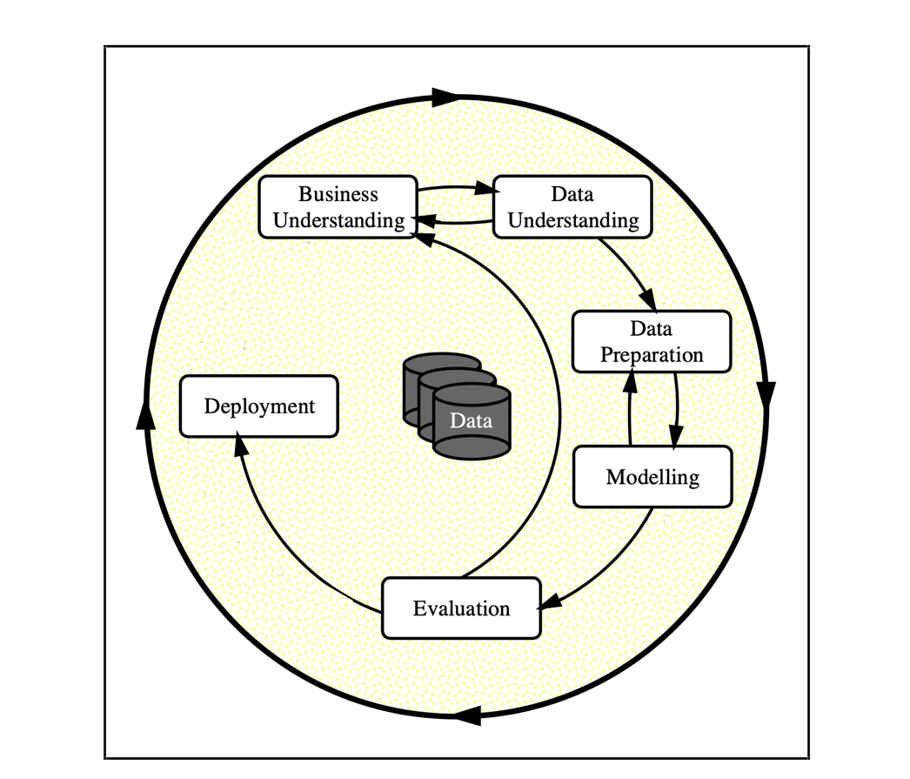

Figure

### Figure 3: CRISP-DM (Wirth et al., No date)

Data Preparation – It is the stage where the final dataset is being prepared. However, the activities in this phase depend on the original data, these activities are likely to be performed multiple times. The preparation would include choosing the proper table for the dataset, record, and transformation of the different attributes in Appendix 2. It is also important to carry out classification, normalisation, and sampling of the datasets. It is also important to note if there are any images in the dataset need to be prepared for AI in medical imaging (Niaksu, 2019).

### The Data Preparation steps for ABM Hospital are the following:

-       Missing Data – it is possible for this to happen that could impact the data analysis negatively, for his reason the analysing algorithm has to be modelled as an ordinary value. After the issue has been internalised, the analysis could resume to normal, but the missing values would not be accessible to the algorithm.  There is also the possibility of a random data missing. In this case it would be significantly easy to get proper analysis and does not necessarily have to deplete entire cases (Wang 2003)

-       Data Sampling – is a type of analysis used for the selection, manipulation and analysing the data subset points in order to find patterns and tendencies in bigger data sets that are being examined. This type of data analysis is very useful and more cost effective in large data analytics applications and surveys are being carried out (Biscobing, 2021)

-      Free turning outliers – the outliers are the parts of data that do not comply with the rest of the data. They are disregarded in normal analysis as exemptions or noise, this kind of analysis could be particularly useful for detecting fraudulent activity on bank cards by discovering irregular purchases or big amounts of money received by bank accounts in a parallel to usual charges to the same (Han et al., 2012)

* Cluster Analysis - this is another data mining technique in which objects are being grouped based on maximising and minimising the intra class similarity. This types of objects form clusters by having high similarity with one another and each cluster can be found in class of objects of which rules can be obtained (Han et al., 2012)

-       Data conversion - this is an important step in data analytics where the data is being converted from one type of format into another, which therefore, helps data analysts to interpret and analyse the data they are working with. Migrating the data from one format to another could be useful for the unlocking of new insights that might have been unnoticed prior to the conversion. This type of data analysis is used for accessibility reasons (Safe, 2021).

* Data Blending – Also known as fusion is a type of data operation where the data set is made of two or more independent data sets, the process is also a not one-time task by it is defined based on what the algorithm would recommend (Jones, 2017).

- Data Trimming - also known as data prunting is a data mining technique that could be linked to decision trees.  This technique decreases the size of the trees by removing those parts that do not secure power for the distribution of instances within the database. How it works is by deciding the data into a smaller subsets repeatedly, and the final result means that there are one or few data points left in the subsets which are often lay called leaves (Hoare, 2021)

Last thing to discuss in this part will be the importance of good data preparation. Firstly, in order for the data to be accessible and easy to use by users, companies see the data preparation as an important instrument to improve the way data is being distributed. Some of the key positives of implementing data preparation are as follows: Its methods enable for structuring raw data thus helping organisation to start making better and more informed decisions. It also makes the data more accessible for internal and external users such as customers, partners, suppliers etc. More structured, quality and accuracy improved data also enables for higher processing speeds. Last but not least. The implementation of the data preparation tools enables for higher value of the data itself as well as higher quality data analysis (Hans, 2019).

### 3.0.2 – CVDs Machine Learning Algorithms

**Supervised Learning** would be the best data mining method to use for this kind of datasets (Appendix 2) because there are target values that need predicting. Furthermore, it is the most appropriate option when there are numeric values within the dataset (Cloud Tweaks)

When it comes to raw unstructured or semi-structured data of binary (0s and 1s) nature (diabetes, anaemia etc. in Appendix 2) best option would be predictive algorithms. First suggestion would be the so-called decision trees. They are powerful simplified form of multi-variation analysis which main purpose is into splitting the data into in a branch looking like sections. Furthermore, after the partition of data in subsets that are divided into categories of variables that would help to understand the subject’s decision making. The second-best option would be Regression which could be linear or logistic. This type of analysis is one of the most wide used in statistics. What it does basically is that it estimates the relationships between the different entities in the dataset and finds their key patterns and how they relate to one another (Wakefield, 2021).

The rest of the data that does not have a binary nature would be best if it is examined by **unsupervised algorithm**. This type of method aims to find correlation and relationships through analysing the available data. The way it works is that is left to interpret large datasets by organising them accordingly, which could lead into grouping them into clusters or arranging them in way where they look more organized. There are two main methods: first one is clustering which is grouping the similar datasets based on specified criteria and it is most useful when the datasets are grouped into several categories for the application of data analysis aiming to find patterns between the different groups. Second is the dimension reduction which reduces the number of variables that are being considered for finding the required information accurately (Wakefield, 2021).

Word count: 1,135

## 4.0 Business Intelligence – Tableau

### 4.0.1 Data Integrity Checks

Once opened and loaded on Tableau the data will be displayed as a data source tab and a sheet. While in the data source tab the data analyst should check for the data types. Which in this case are numbers for Orders ID, Quantity Order and Price Each, it is string for the product and purchase address and a date and time for the order date. Since having Order ID, Product, Quantity Order and Price Each it is safe to conclude that the Order’s total field is missing. The next thing that needs checking is the description in each field. After checking all columns are valid which is good, some of them did not have their domain loaded and it had to be manually loaded. Lastly, in the tableau sheet it could be checked that Tableau divides the data columns in to two sections: all of the dimensions and all of the measures (Jurgon, 2021). It also needs to calculate the profit each, sales each and unit’s price (all in Figure 12). A further brake down of the address is also needed which would be breaking down the orders by Address Breakdown (consisting of number and street), by City and by zip code. All thanks to Dreamer (2020) which also recommended a further break down of the date which is not really necessary for this task.



### Figure 4: Data breakdown

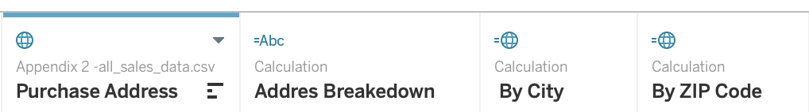

Figure

### Figure 5: Address Breakdown

### 4.0.2 Warranty End Date calculation

﻿DATEADD('month', 14, [Order Date])

By selecting DATEADD the analyst can add date in months and in case of this one the added time is 14 months (Figure 22) as a contingency (Jurgon, 2021).

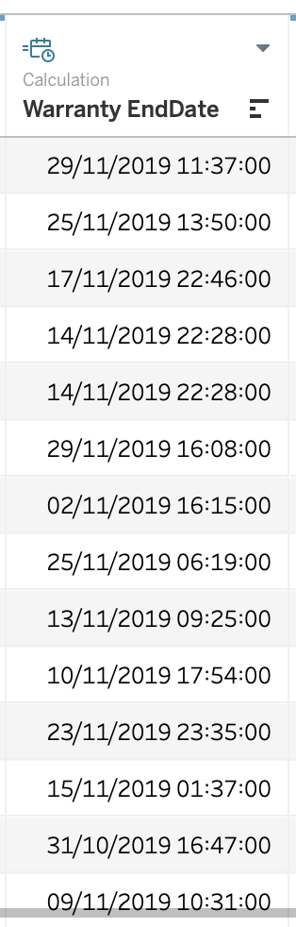

### Figure 22: Warranty End Date

### 4.0.3 Total Sales By City (highest to lowest)

Figure 15 below consist of the highest to lowest sales by city, which was done by dragging and dropping the necessary elements (sum of sales each and by city) and sorting them from highest to lowest (Tableau Step 4, 2021).

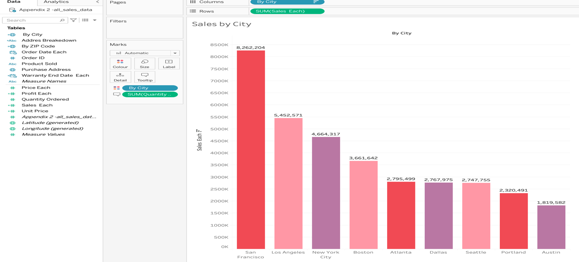

### Figure 6

### 4.0.4 Cities generating more than 3 million US dollars for 2019

In Figure 16 are shown the four cities that made over 4 million US dollars 2019. This was achieved by dragging and dropping order date each and sales each into the columns section plus by city to the rows section. Furthermore, a filter needed adding in order to display the specific cities (Tableau Step 5, 2021).

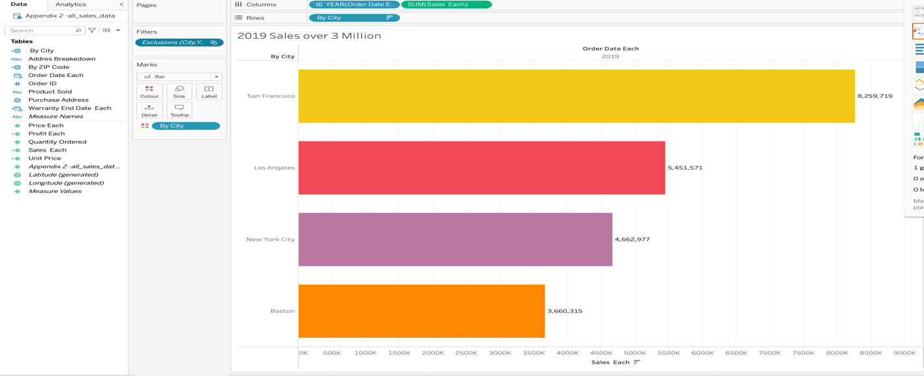

### Figure 7: Cities generating more that 3 million US dollars

### 4.0.5 Top selling Products

Here after using the product sold as Cullum and then putting order date each plus sales each in the rows section. Filters are added to the sales to display them as well as the order date which was limited to 2019 only. Last thing needed for this task was to add the quantity ordered through which tableau can be programed to show quantity sold in numbers, and the products sold where only the top 5 products would be selected manually (Tableau Step 5, 2021).

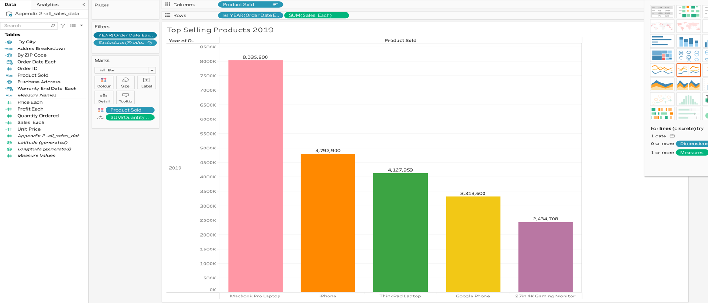

### Figure 8

### 4.0.6 Sales By month for 2019

What needs to be done in this part is for the rows to add the sales, and after that in the categories section the order date needs to be added three times as the first time the order date needs to be programmed for to show the year as well as in the filter, then the second one to show the quarter, the third for the month, as well as in the filter. Lastly, the brighter colours are to indicate increasing sales where darker colours show decreasing sales (Tableau Step 5, 2021).

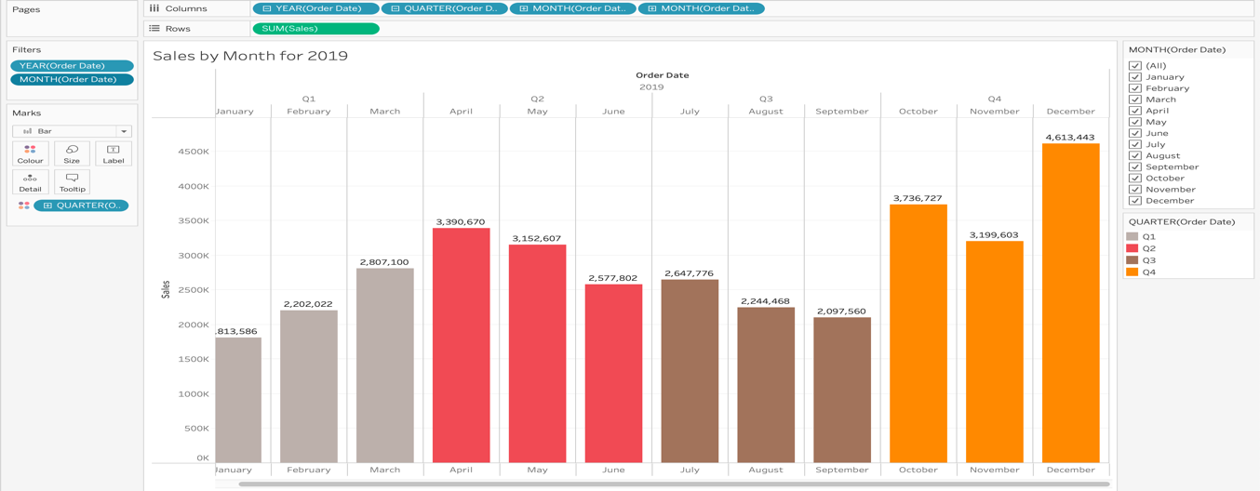

### Figure 9

### 4.0.7 Sales and Profit for 2019

In this part the columns need to include Order Date selected for year alongside the measure values. In the rows need to include the products and the measure names. In the filter the year needs to be set for 2019, and the measure names have to be set for profit per order and the sales (Tableau Step 6 & 7, 2021).

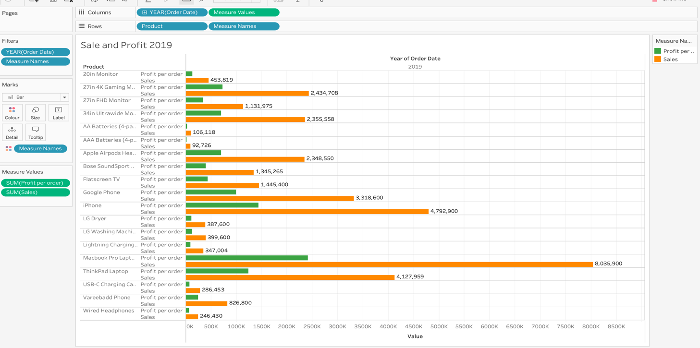

### Figure 10

### 4.0.8 Maximum Sales for Boston, Los Angeles, Seattle and New York.

This part is fairly simple to achieve. Firstly, to display the cities need to be added (dragged and dropped) and filtered by manually selecting the selecting the four cities that are needed. Secondly, in the rows by adding the sales and then selecting to display the maximum sales (Tableau Step 5, 2021).

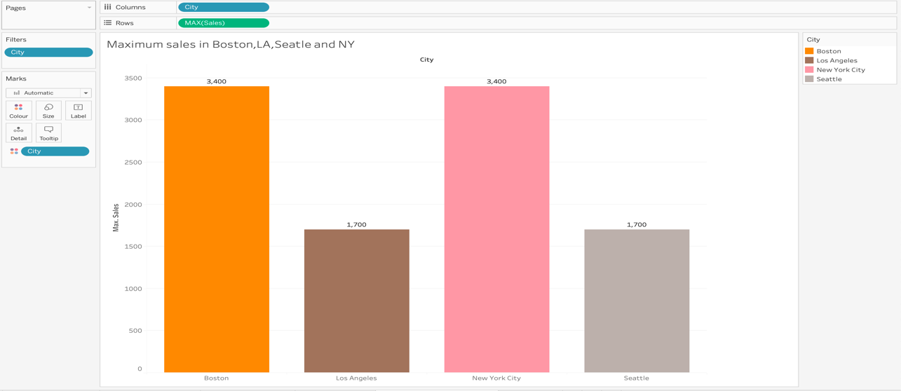

### Figure 11

### 4.0.9 Dashboard for tasks 3,4,5 & 6.

What was done in this part was simply by selecting to create a new dashboard window and then from the sheets area dragging and dropping the sheets from tasks 3, 4, 5 & 6. Please note that I checked create a dashboard on the Tableau (2021) website, however this task was done by using my common sense and not guidance from Tableau’s website.

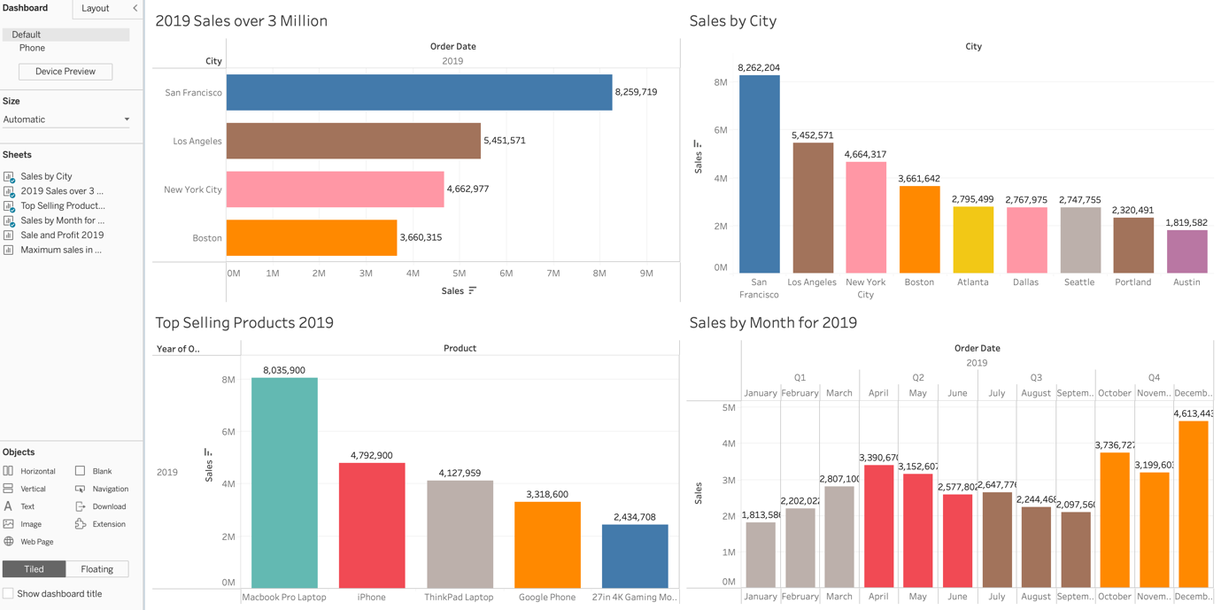

### Figure 12: Dashboard for tasks 3-6

## References

Han, J., Kamber, M. & Pei, J. (2012) *Data Mining Concepts and Techniques*. 3rd edn. Elsevier Inc.: Waltham, MA, USA

Inmon, W.H. (2002) *Building the Data Warehouse*. 3rd edn. John Wiley & Sons, Inc.: Toronto, Canada

Kimball, R. & Ross, T. (2013) *The Data Warehouse Toolkit*. 3rd edn. John Wiley & Sons, Inc.: Indianapolis, IN, USA

Rob, P. & Coronel, C. (2009) *Database Systems: Design, Implementation, and Management*. 8th edn. Course Technology: Boston, MA, USA

Wang, J, (2003) *Data Mining: Opportunities and Challenges.* 1st edn. Idea Group Publishing: Hershey, PA, USA

Jatana, N., Puri, S., Ahuja, M., Kathuria, I. & Gosain, D. (2012) *A Survey And Comparison Of Relational And Non-Relational Base. International Journal Of Engineering Research & Technology*. 1 (6) pp. 1-5. Available at:

<https://citeseerx.ist.psu.edu/viewdoc/download?doi=10.1.1.678.9352&rep=rep1&type=pdf>

(Accessed: 11/4/2021)

Niaksu, O. (2015) *CRISP Data Mining Methodology Extension For Medical Domain.* Baltic J. Modern Computing. 3 (2) pp. 92-109. Available at:

<https://www.bjmc.lu.lv/fileadmin/user_upload/lu_portal/projekti/bjmc/Contents/3_2_2_Niaksu.pdf>

(Accessed: 24/4/2021)

Biscobing, J. (2021) *Data Sampling*. Available at:

<https://searchbusinessanalytics.techtarget.com/definition/data-sampling> (Accessed: 8/5/2021)

Becker, R. (2021) *Structured Query Language (SQL).* Available at:

<https://www.techopedia.com/definition/1245/structured-query-language-sql> Accessed: 16/3/2021)

Blue, J. (2012) *How To Use SQL in Statement With Subquery*. Available at:

<https://www.youtube.com/watch?v=ZmEpW-RVWxY> (Accessed: 2/3/2021)

Cave Of Programming (2016) *My SQL Begginers 0006: Null and Not Null Values*. Available at:

<https://www.youtube.com/watch?v=Ja4F4PcqrBc> (Accessed; 3/3/2021)

CloudTweaks (2021) *When To Use Supervised and Unsupervised Data Learning*. Available at:

<https://cloudtweaks.com/2014/09/supervised-unsupervised-data-mining/> (Accessed: 15/4/2021)

Dreamer, A. (20200 *How To Prepare Data For Tableau Guide: Step By Step.* Available at:

<https://www.xplenty.com/blog/xplenty-tableau-step-by-step/> (Accessed: 29/4/2021)

Guru99 (2021) *SQL vs NOSQL*. Available at:

<https://www.guru99.com/sql-vs-nosql.html> (Accessed: 12/4/2021)

Hoare, J. (2021) *Machine Learning: Pruning Decision Trees*. Available at:

<https://www.displayr.com/machine-learning-pruning-decision-trees/> (Accessed: 8/5/2021)

Hans, S. (2019) *7 Reasons Data Preparation Is Important*. Available at:

[https://adeptia.com/blog/7-reasons-data-preparation-is-importan](https://adeptia.com/blog/7-reasons-data-preparation-is-important)t  (Accessed: 23/4/2021)

Jones, M. (2017) *Working With Messy Data*. Available at:

<https://developer.ibm.com/tutorials/ba-cleanse-process-visualize-data-set-1/> (Accessed: 9/5/2021)

Jurgon, P. (2021) *Data warehouse: Star Schema*. Available at:

<https://eu.bbcollab.com/collab/ui/session/playback> (Accessed:

Jurgon, P. (2021) *Introduction To Tableau Part 3*. Available at:

<https://youtu.be/3PcMn3gZlDw> (Accessed: 23/4/2021)

Jorgi, B. (2014) *SQL Server: DDL and DML Commands*. Available at:

<https://www.youtube.com/watch?v=Am1wIwKQWOo> (Accessed: 1/3/2021)

Kudvenkat (2012) *Self Join In SQL server Part 14*. Available at:

<https://www.youtube.com/watch?v=qnYSN_7qwgg> Accessed: 6/3/201)

Luthra, A. (2018) *Joins In SQL*. Available at:

<https://www.youtube.com/watch?v=M74w28kdbQg> (Accessed: 5/3/2021)

LucidChart (2017) *Entity Relationship Diagram (ERD) Tutorial Part 1*. Available at:

<https://www.youtube.com/watch?v=QpdhBUYk7Kk> ( Accessed: 16/2/2021)

MongoDB (2021) *Advantages of NOSQL*. Available at:

<https://www.mongodb.com/nosql-explained/advantages> (Accessed: 17/3/2021)

MySQL Forum (2021) *MySQL Tutorials*. Available at:

<https://downloads.mysql.com/docs/mysql-tutorial-excerpt-5.7-en.pdf> (Accesed: 5/4/2021)

Panwar, A. (2020) *DDL, DML And DCL In MySQL*. Available at:

<https://www.c-sharpcorner.com/UploadFile/65fc13/ddldml-and-dcl-in-mysql/> (accessed: 1/3/2021)

Poojary, D. (2021) *Type of NOSQL Databases and its Comparison To Relational Databases.* Available at:

h[ttps://www.researchgate.net/profile/Dikshay-Poojary/publication/302557703_Article_Type_of_nosql_databases_and_its_comparison_with_relational_databases/links/5aeaa2b50f7e9b837d3c40e7/Article-Type-of-nosql-databases-and-its-comparison-with-relational-databases.pdf](https://www.researchgate.net/profile/Dikshay-Poojary/publication/302557703_Article_Type_of_nosql_databases_and_its_comparison_with_relational_databases/links/5aeaa2b50f7e9b837d3c40e7/Article-Type-of-nosql-databases-and-its-comparison-with-relational-databases.pdf) (17/3/2021)

QAFox (2020) *SQL Part 28: Gratest And Least SQL Functions.* Available at;

<https://www.youtube.com/watch?v=ftykz7QgL6A> (accessed; 19/3/2021)

Solenz, D.L. (2021) *What are the advantages of Relational Data Model.* Available at:

<https://www.techwalla.com/articles/what-are-the-advantages-of-a-relational-database-model> (Accessed: 1/4/2021)

Safe (2021) *What Is Data Conversion.* Available at:

<https://www.safe.com/what-is/data-conversion/> (Accessed: 9/5/2021)

TheNewBoston (2012) *MySQL Database Tutorial 19: Group By.* Available at:

<https://www.youtube.com/watch?v=_uyyc5fc3J8> (Accessed: 4/3/2021)

Tables Help (2021) *Step 4: Explore Your Data Geeoraphically.* Available at:

<https://help.tableau.com/current/guides/get-started-tutorial/en-us/get-started-tutorial-explore.htm> (Accessed: 7/5/2021)

Tableau Help (2021) *Step 5: Drill Down The Detail*. Available at:

<https://help.tableau.com/current/guides/get-started-tutorial/en-us/get-started-tutorial-drilldown.htm> (accessed: 7/5/2021)

Tableau Help (2021) *Step 6: Build A Dashboard To Show Your Insights.* Available at:

<https://help.tableau.com/current/guides/get-started-tutorial/en-us/get-started-tutorial-build.htm> (Accessed: 9/5/2021)

Tableau Help (2021) *Step 7: Build A Story To Present.* Available At:

<https://help.tableau.com/current/guides/get-started-tutorial/en-us/get-started-tutorial-story.htm> (Accessed: 9/5/2021)

Tableau (2021) *Create A Dashboard.* Available at:

<https://help.tableau.com/current/pro/desktop/en-us/dashboards_create.htm> (Accessed: 9/5/2021)

Wirth, R. & Hipp, J. (No Date) *CRISP-DM: Towards A Standard Process Model For Data Mining*: Available at:

<http://www.cs.unibo.it/~danilo.montesi/CBD/Beatriz/10.1.1.198.5133.pdf>

(Accessed: 24/4/2021)

Wakefield, K. (2021) *Predictive Analytics And Machine Learning.* Available at:

<https://www.sas.com/en_gb/insights/articles/analytics/a-guide-to-predictive-analytics-and-machine-learning.html>

(Accessed: 25/4/2021)

Wakefield, K. (2021) *A Guide To The Types Of Machine Learning Algorithms.* Available at:

<https://www.sas.com/en_gb/insights/articles/analytics/machine-learning-algorithms.html>

(Accessed: 25/4/2021)